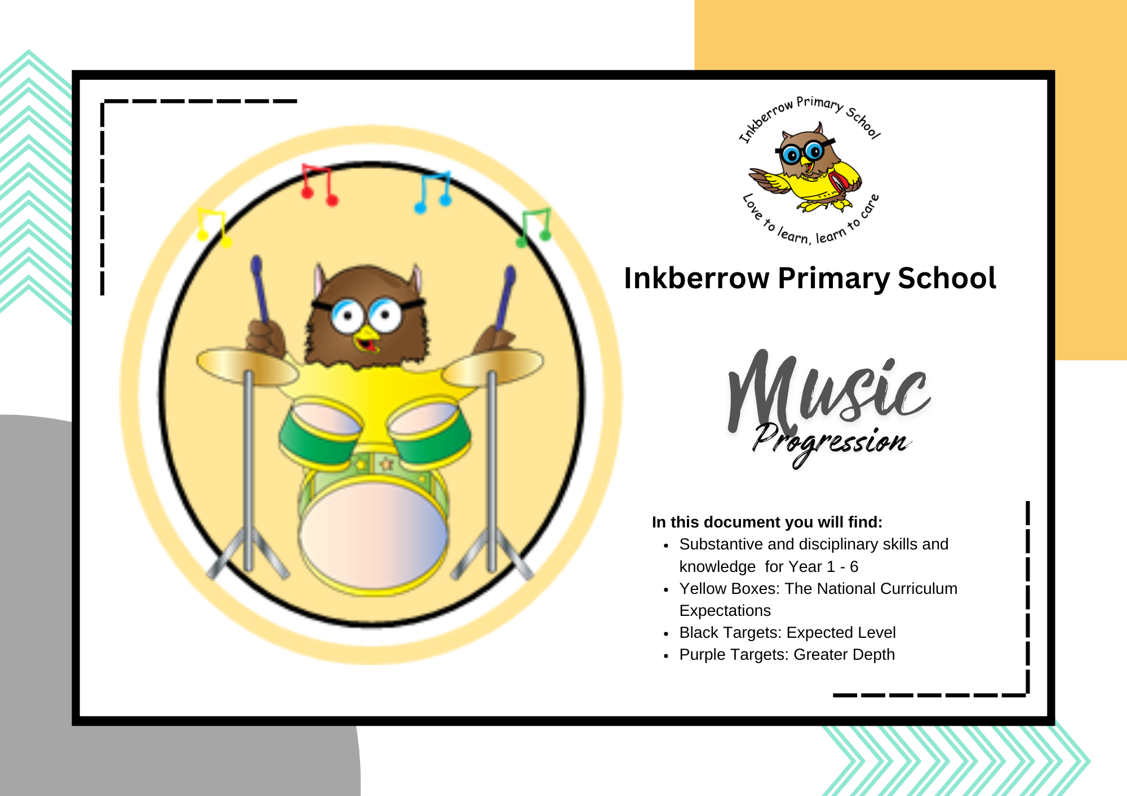
Music Curriculum Map 2023
National Curriculum Key Stage 1
In music pupils should be taught to:
• use their voices expressively by singing songs and speaking chants and rhymes
• play tuned and un-tuned instruments musically
• listen with concentration and understanding to a range of high-quality live and recorded music
• make and combine sounds using the inter-related dimensions of music.
National Curriculum Key Stage 2
Pupils should be taught to:
• play and perform in solo and ensemble contexts, using their voices and playing musical instruments with increasing accuracy, fluency, control and expression
• improvise and compose music using the inter-related dimensions of music
• listen with attention to detail and recall sounds with increasing aural memory
• use and understand staff and other musical notations
• appreciate and understand a wide range of high-quality live and recorded music from different traditions and from great composers and musicians
• develop an understanding of the history of music.
Skills Progression
Year Group | Listening and Appraising | Singing | Playing | Composing | Performing
Reception | ● To learn that music can touch your feelings.  ● To enjoy moving to music by dancing, marching, being animals or Pop stars. | ● To sing along with a pre-recorded song and add actions.  ● To sing along with the backing track. | ● To play along with a pre-recorded song and add actions.  ● To play along with the backing track. |  | ● Perform any of the nursery rhymes by singing and adding actions or dance.  ● Perform any nursery rhymes or songs adding a simple instrumental part. ● Record the performance to talk about.  Including Nativity
Year 1 | ● To learn how they can enjoy moving to music by dancing, marching, being animals or pop stars. | ● Learn about voices, singing notes of different pitches (high and low).  ● Learn that they can make different types of sounds with their voices – you can rap or say words in rhythm.  ● Learn to start and stop singing when following a leader. | ● Treat instruments carefully and with respect.  ● Play a tuned instrumental part with the song they perform.  ● Learn to play an instrumental part that matches their musical challenge, using one of the differentiated parts (a one-note part, a simple part, medium part).  ● Listen to and follow musical instructions from a leader | ● Help to create a simple melody using one, two or three notes.  ● Learn how the notes of the composition can be written down and changed if necessary. | ● Choose a song they have learnt from the Scheme and perform it.  ● They can add their ideas to the performance.  ● Record the performance and say how they were feeling about it.  Including Nativity
Year 2 | ● To learn how they can enjoy moving to music by dancing, marching, being animals or pop stars.  ● To learn how music can tell a story or describe an idea.  ● To learn how music can tell a story or describe an idea. | ●Learn about voices singing notes of different pitches (high and low).  ● Learn that they can make different types of sounds with their voices – you can rap (spoken word with rhythm).  ● Learn to find a comfortable singing position.  ● Learn to start and stop singing when following a leader. | ● Treat instruments carefully and with respect.  ● Learn to play a tuned instrumental part that matches their musical challenge, using one of the differentiated parts (a one-note, simple or medium part).  ● Play the part in time with the steady pulse.  ● Listen to and follow musical instructions from a leader. | ● Help create three simple melodies with the Units using one, three or five different notes.  ● Learn how the notes of the composition can be written down and changed if necessary. | ● Choose a song they have learnt and perform it.  ● They can add their ideas to the performance.  ● Record the performance and say how they were feeling about it  Including Nativity
Year 3 | ● To confidently identify and move to the pulse.  ● To think about what the words of a song mean.  ● To take it in turn to discuss how music makes them feel.  ● Listen carefully and respectfully to other people’s thoughts about the music. | To sing in unison and in simple two-parts.  ● To demonstrate a good singing posture.  ● To follow a leader when singing.  ● To enjoy exploring singing solo.  ● To sing with awareness of being ‘in tune’.  ● To have an awareness of the pulse internally when singing. | ● To treat instruments carefully and with respect.  ● Play any one, or all of four, differentiated parts on a tuned instrument – a one-note, simple or medium part or the melody of the song) from memory or using notation.  ● To rehearse and perform their part within the context of the Unit song.  ● To listen to and follow musical instructions from a leader.  Learn to play an instrument through FAME (Clarinet) | ● Help create at least one simple melody using one, three or five different notes.  ● Plan and create a section of music that can be performed within the context of the unit song. ● Talk about how it was created.  ● Listen to and reflect upon the developing composition and make musical decisions about pulse, rhythm, pitch, dynamics and tempo.  ● Record the composition in any way appropriate that recognises the connection between sound and symbol (e.g. graphic/pictorial notation). | ● To choose what to perform and create a programme.  ● To communicate the meaning of the words and clearly articulate them.  ● To talk about the best place to be when performing and how to stand or sit.  ● To record the performance and say how they were feeling, what they were pleased with what they would change and why.
Year 4 | ● To confidently identify and move to the pulse.  ● To talk about the musical dimensions working together E.g. if the song gets louder in the chorus (dynamics).  ● Talk about the music and how it makes them feel.  ● Listen carefully and respectfully to other people’s thoughts about the music.  ● When you talk try to use musical words. | ● To sing in unison and in simple two-parts.  ● To demonstrate a good singing posture.  ● To follow a leader when singing.  ● To enjoy exploring singing solo.  ● To sing with awareness of being ‘in tune’.  ● To re-join the song if lost.  ● To listen to the group when singing. | ● To treat instruments carefully and with respect.  ● Play any one, or all four, differentiated parts on a tuned instrument – a one-note, simple or medium part or the melody of the song from memory or using notation.  ● To rehearse and perform their part.  ● To listen to and follow musical instructions from a leader. (Ukulele)  ● To experience leading the playing by making sure everyone plays in the playing section of the song. | ● Help create at least one simple melody using one, three or all five different notes using notation  ● Plan and create a section of music that can be performed within the context  ● Talk about how it was created.  ● Listen to and reflect upon the developing composition and make musical decisions about pulse, rhythm, pitch, dynamics and tempo.  ● Record the composition in any way appropriate that recognises the connection between sound and symbol (e.g. graphic/pictorial notation). | ● To choose what to perform and create a programme.  ● Present a musical performance designed to capture the audience.  ● To communicate the meaning of the words and clearly articulate them.  ● To talk about the best place to be when performing and how to stand or sit.  ● To record the performance and say how they were feeling, what they were pleased with what they would change and why.  Carols and Cuppas
Year 5 | ● To identify and move to the pulse with ease.  ● To think about the message of music.  ● To compare two songs in the same style, talking about what stands out musically in each of them, their similarities and differences.  ● Listen carefully and respectfully to other people’s thoughts about the music.  ● When you talk try to use musical words.  ● To talk about the musical dimensions working together in the Unit songs. ● Talk about the music and how it makes you feel. | ● To sing in unison and to sing backing vocals.  ● To enjoy exploring singing solo. To listen to the group when singing.  ● To demonstrate a good singing posture.  ● To follow a leader when singing.  ● To experience rapping and solo singing.  ● To listen to each other and be aware of how you fit into the group.  ● To sing with awareness of being ‘in tune’. | ● Play a musical instrument with the correct technique within the context of the Unit song.  ● Select and learn an instrumental part that matches their musical challenge, using one of the differentiated parts – a one-note, simple or medium part or the melody of the song from memory or using notation.  ● To rehearse and perform their part  ● To listen to and follow musical instructions from a leader.  ● To lead a rehearsal session. | ● Create simple melodies using up to five different notes and simple rhythms that work musically with the style of the Unit song.  ● Explain the keynote or home note and the structure of the melody.  ● Listen to and reflect upon the developing composition and make musical decisions about how the melody connects with the song.  ● Record the composition in any way appropriate that recognises the connection between sound and symbol (e.g. graphic/pictorial notation). | ● To choose what to perform and create a programme.  ● To communicate the meaning of the words and clearly articulate them.  ● To talk about the venue and how to use it to best effect.  ● To record the performance and compare it to a previous performance.  ● To discuss and talk musically about it – “What went well?” and “It would have been even better if...?”
Year 6 | ● To identify and move to the pulse with ease.  ● To think about the message of songs.  ● To compare two pieces of music in the same style, talking about what stands out musically in each of them, their similarities and differences.  ● Listen carefully and respectfully to other people’s thoughts about the music.  ● Use musical words when talking about the songs.  ● To talk about the musical dimensions working together in the Unit songs. ● Talk about the music and how it makes you feel, using musical language to describe the music. | ● To sing in unison and to sing backing vocals.  ● To demonstrate a good singing posture.  ● To follow a leader when singing.  ● To experience rapping and solo singing.  ● To listen to each other and be aware of how you fit into the group.  ● To sing with awareness of being ‘in tune’. | ● Play a musical instrument with the correct technique within the context of the Unit song.  ● Select and learn an instrumental part that matches their musical challenge, using one of the differentiated parts – a one-note, simple or medium part or the melody of the song from memory or using notation.  ● To rehearse and perform their part  ● To listen to and follow musical instructions from a leader.  ● To lead a rehearsal session.  Ukulele Lessons for 1 term | ●Create simple melodies using up to five different notes and simple rhythms that work musically with the style of the Unit song.  ● Explain the keynote or home note and the structure of the melody.  ● Listen to and reflect upon the developing composition and make musical decisions about how the melody connects with the song.  ● Record the composition in any way appropriate that recognises the connection between sound and symbol (e.g. graphic/pictorial notation). | ● To choose what to perform and create a programme.  ● To communicate the meaning of the words and clearly articulate them.  ● To talk about the venue and how to use it to best effect.  ● To record the performance and compare it to a previous performance.  ● To discuss and talk musically about it – “What went well?” and “It would have been even better if...?”  Leavers Play
Whole School | Weekly Live Music in Assembly  Music Appreciation links in Newsletters | Whole School Singing Practice weekly  Choir | FAME  Ukulele in Y4-6  Glockenspiel / Recorder  Peripatetic Lessons (Drums, guitar, woodwind, violin) |  | Nativity  Choir  Easter Performance  Carols and Cuppas  Key Stage 2 Christmas Concert  Year 6 Leavers’ Play  Year 6 Leavers’ Performance  Peripatetic Performances

