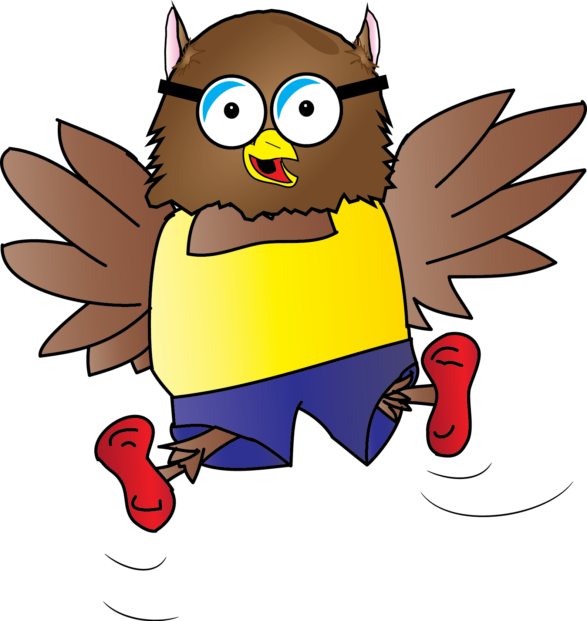

In this document you will find:
- Skill progression for Year 1 – Year 6
- Green skills = ARE expectation for coverage and attainment
- Purple skills = Challenge and working at Greater Depth in the area
- Bright Yellow boxes = National Content and Coverage
- Pale Yellow boxes = key skills for subjects
Physical Education Curriculum Map
Inkberrow Primary School

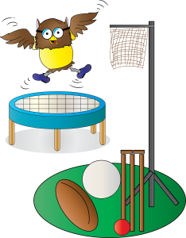Physical Education Curriculum Map
KEY STAGE ONE:
Progression | Master basic movements including running, jumping, throwing and catching, as well as developing balance, agility and coordination, and begin to apply these in a range of activities
Year Group | Assessment Criteria | AUTUMN | SPRING | SUMMER
YEAR R | ELG Physical Development  This involves providing opportunities for children to be active and interactive, and to develop their co-ordination, control, and movement. Children must also be helped to understand the importance of physical activity, and to make healthy choices in relation to food.  ELG 04 Moving and handling:  *Children show good control and co-ordination in large and small movements  *They move confidently in a range of ways, safely negotiating space  *They handle equipment and tools effectively (including pencils for writing) | Movement and Space  Gymnastics  Dance (Nativity) | Swimming  Dance  Athletics | Rounders/Cricket  Multi-sports
YEAR 1 | A Year 1 Sports Person can:  *Throw underarm *Hit a ball with a bat *Move and stop safely *Throw and catch with both hands *Throw and kick in different ways  *Copy actions *repeat actions and skills *move with control and care *use equipment safely | Dance/Gymnastics  Games (Net/Wall) | Gymnastics  Skipping  Invasion Games | Athletics  Striking and Fielding
YEAR 2 | A Year 2 Sports Person can:  *Change rhythm, speed, level and direction in dance routine *Dance with control and coordination *make a sequence by linking sections together *uses dance to show a mood or feeling  *Hit, kick and roll in a game *decides the best space to be in *Use one tactic in a game *Follows rules  *Plan and perform a sequence of movements *Improves sequence based on feedback *Think of more than one way to create to create a sequence which follows the same ‘rules’ *works alone and with a partner | Dance  Games (Net/Wall)  Games (Invasion) | Dance/Gymnastics  Striking & Fielding | Athletics
Progression | Participate in team games, developing simple tactics for attacking and defending
YEAR 1 | As above | Games (Net/wall)  Games (Invasion) | Striking and Fielding
YEAR 2 | As above | Games (Net/Wall | Games
Progression | Perform dances using simple movement patterns.
YEAR 1 | *Make their body curled, tensed, stretched and relax *control their body when travelling and balancing *copy sequences and repeat them *roll, curl, travel and balance in different ways  *Move to music *copy dance moves *perform their own dance moves *make up a short dance *move safely in a space | Dance/Gymnastics | Gymnastics
YEAR 2 | As above | Dance | Dance/Gymnastics
Progression | Swimming and Water Safety:  Swim competently, confidently and proficiently over a distance of at least 25 metres. Use a range of strokes effectively [for example, front crawl, backstroke and breaststroke]  Perform safe self -rescue in different water based situations.
YEAR R |  |  | Swimming
YEAR 1 |  |  | Swimming | Swimming
YEAR 2 |  |  |  | Swimming

KEY STAGE TWO: YEARS 3, 4 and 5 (Year 6 2020)
Progression | Use running, jumping, throwing and catching in isolation and in combination. Play competitive games, modified where appropriate [for example, badminton, basketball, cricket, football, hockey, netball, rounders and tennis] and apply basic principles suitable for attacking and defending.  Develop flexibility, strength, technique, control and balance [for example through athletics and gymnastics]  Perform dances using a range of movement patterns take part in outdoor and adventurous activity challenges both individually and within a team.  compare their performances with previous ones and demonstrate improvement to achieve their personal best.
Year Group | Assessment Criteria | AUTUMN | SPRING | SUMMER
YEAR 3 | A Year 3 sports persons can:  *Throw and catch with control *be aware of space *Cause problems for the opposition *use rules fairly  *Adapt sequences for different audiences *Explain how strength and suppleness affects performance *compare and contrast sequences  *improvise freely and translate ideas *share and create phrases with a partner *repeat, remember and perform phrases  *run at differing speeds *change direction *take part in a relay race  *follow a map in a familiar context *use clues to follow a route *follow a route safely. | Games (Net/wall)  Gymnastics | Dance  Invasion Games | Athletics  Cricket/Rounders  (Fitness week, sports day)
YEAR 4 | A Year 4 Sports Person can:  *catch with one hand *throw and catch accurately *hot a ball with control *Keep possession of the ball *vary tactics and skills depending on the game.  *work in a controlled way *include a change in speed and direction *include a range of shapes *work with a partner to create, repeat and improve a sequence with at least 3 phrases  *take the lead when working with a partner *use dance to communicate an idea  *Run over a long distance *print over a short distance *throw in different ways *hit a target *jump in different ways  *Follow a map in a more demanding contect *follow a route within a time limit. | Dance/Gymnastics  Outdoor Education (Malvern) | Dance/Gymnastics  Invasion Games | Athletics  Rounders
YEAR 5
YEAR 6

PE Resource List
- All PE Equipment in outdoor shed
- Equipment including
- Early Years equipment: (Physical Development)
- Crates
- Drain pipes
- Blue stands
- Big wooden blocks
- Big wooden planks
- Bikes and trikes
- Balls
- Ribbons
- Balancing track
- Foam bricks

