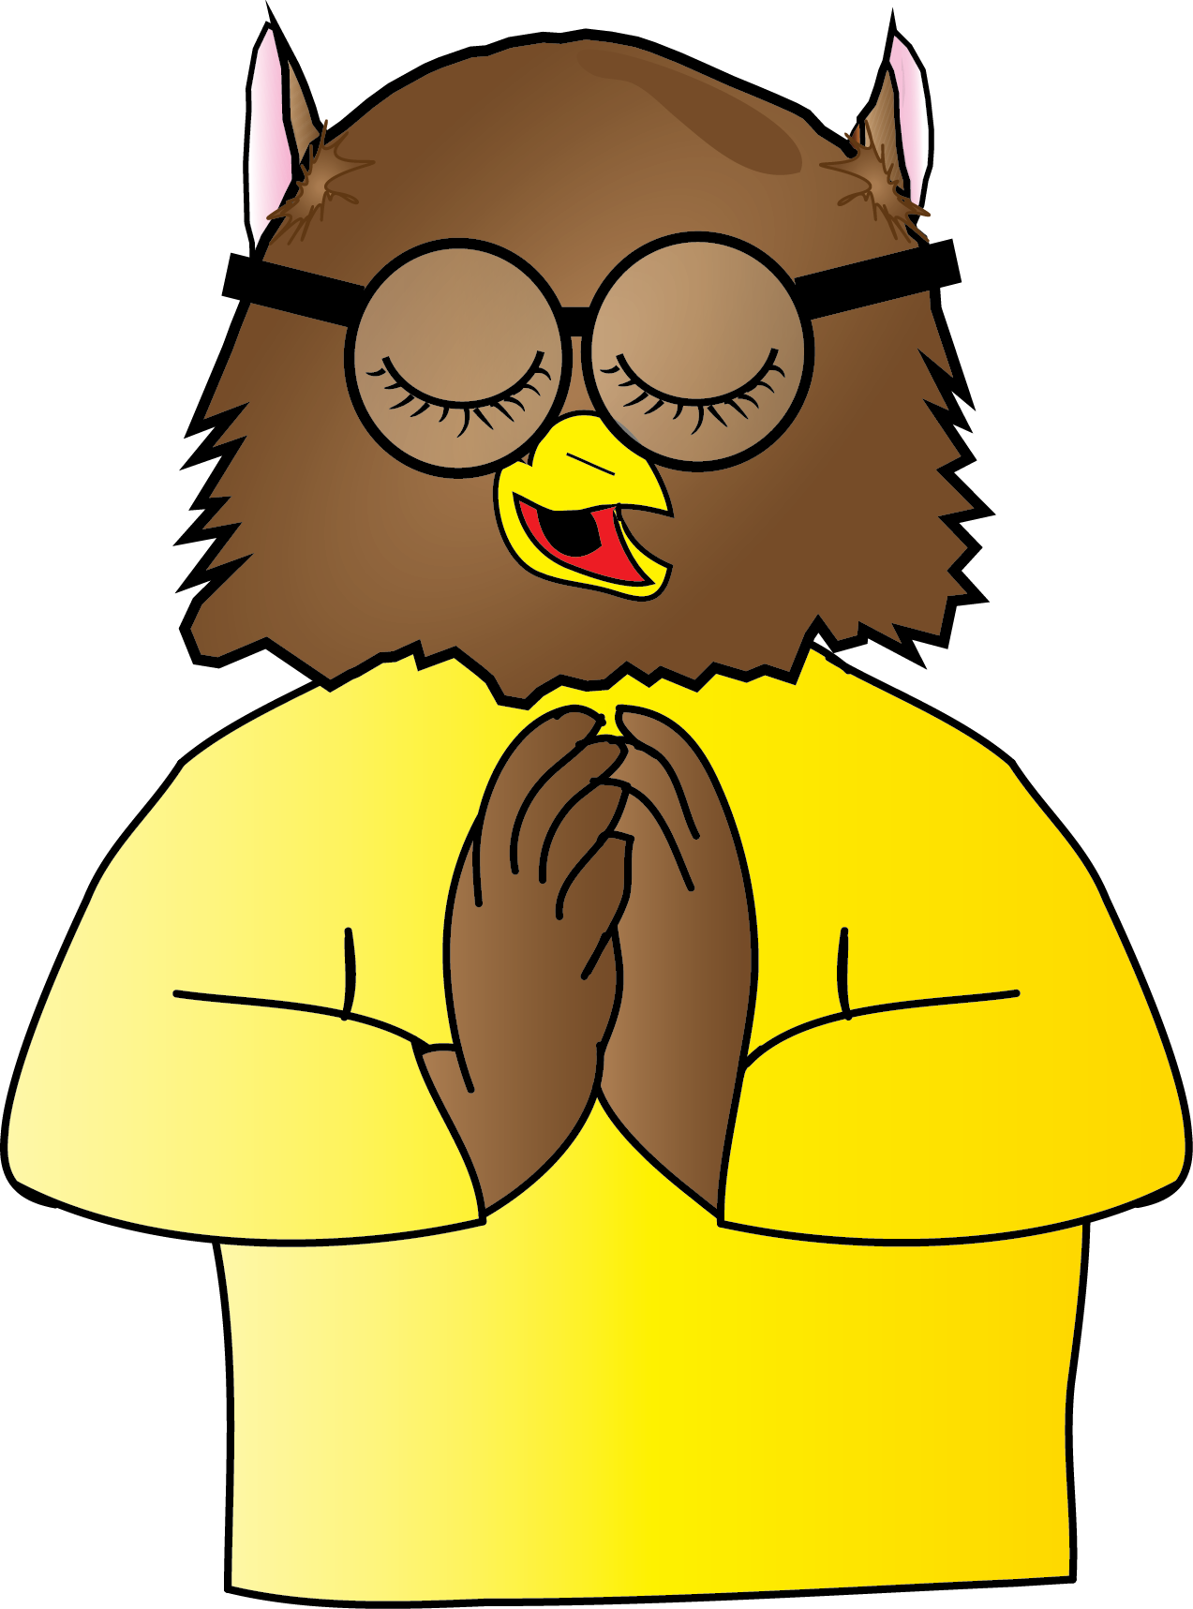
Inkberrow Primary School
Religious Education Curriculum Map
In this document you will find:
- Skill progression for Year 1 – Year 6
- Green skills = ARE expectation for coverage and attainment
- Purple skills = Challenge and working at Greater Depth in the area
- Bright Yellow boxes = National Content and Coverage
- Pale Yellow boxes = key skills for subjects
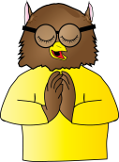RE Curriculum Map

 |  | Autumn Term  1st Half Term | Autumn Term  2nd Half Term | Spring Term  1st Half Term | Spring Term  2nd Half Term |  | Summer Term  1st Half Term | Summer Term  2nd Half Term
Reception |  | F5 Being Special: Where do we belong? | F4 What times are special and why? | F2 Which people are special and why? | F3 What places are special and why? |  | F1 What stories are special and why? | F6 What is special about our world and why?
Strand |  | Living | Expressing | Believing | Expressing |  | Believing | Living
Religions |  | Christians & others faiths | Christians & others faiths | Christians & others faiths | Christians & others faiths |  | Christians & others faiths | Christians & others faiths
Stories |  | Harvest | Rama & Sita  Christmas | Jesus & the twelve disciples – Matthew 4 |  |  | Noah’s Ark – Genesis 6-9  Ten Lepers – Luke 17 | God’s quiet things by Nancy Sweetland  Muhammad & the ant  Tthe thirsty camel  Seven Kittens
Year 1 |  | 1.7 What does it mean to belong to a faith community? | 1.6 How and why do  we celebrate special and sacred times? | 1.1 Who is a Christian and what do they believe? |  | 1.2 Who is a Muslim and what do they believe? | 1.5 What makes some places sacred?  Christians and Muslims
Strand |  | Living | Expressing | Believing |  | Believing | Expressing
Religions |  | Christians, Muslims & Jewish | Christians, Muslims & Jewish | Christians |  | Muslims | Christians, Muslims & Jewish
Stories |  | Harvest | Christmas | Jonah and the Whale  The Lost Son – Luke 15 |  | Muhammad and the cat  The story of the two brothers  The crying camel
 | Year 2 | 1.8 How should we care for others and the world, and why does it matter? | 1.3 Who is Jewish and what do they believe? |  |  | 1.6 How and why do we celebrate special and sacred times? | 1.4 What can we learn from scared books?
 | Strand | Living | Believing |  |  | Expressing | Believing
 | Religions | Christians & Jewish | Jewish |  |  | Chriatians & Jewish | Christians, Jewish & Jewish
 | Stories | The good Samaritan – Luke 10  Creation – Genesis 1 |  |  |  | Jesus’ special friends – Luke 5 | Joesph and his brothers – Genesis 37  The Houses built on the rock and sand – Matthew 7
 | Autumn Term  1st Half Term |  | Autumn Term  2nd Half Term | Spring Term  1st Half Term | Spring Term  2nd Half Term |  | Summer Term  1st Half Term | Summer Term  2nd Half Term
Year 3 | 2.5 Why are festivals important to religious communities? |  |  | L2.1 What do different people believe about God? |  | L2.4 Why do Christians pray? | L2.7 What does it mean to be a Christian in Britain today? | L2.2 Why is the Bible so important for Christians today?
Strand | Expressing |  |  | Believing |  | Expressing | Living | Believing
Religion | Hindus & Christians |  |  | Christians, Hindus or Muslims |  | Christians, Hindus and/or Muslims | Christians | Christians
Stories | Rama & Sita |  |  |  |  | The Lost Sheep – Luke 15 |  | The Fall – Genesis 3  The Lost Coin – Luke 15
Year 4 | 2.5 Why are festivals important to religious communities? | L2.8 What does it mean to be a Hindu in Britain today? |  | L2.6 Why do some people think that life is like a journey and what significant experiences mark this? (Pilgrim’s Quest Worcester Cathedral) |  | L2.3 Why is Jesus inspiring to some people? |  | L2.9 What can we learn from religions about deciding what is right or wrong?
Strand | Expressing | Living |  | Expressing |  | Believing |  | Living
Religion | Jewish & Hindu | Hindu |  | Christians , Jewish and Hindu |  | Christians |  | Christians & Jewish
Stories | Leviticus 23:26 – 32 – Golden Calf (atonement for sins-Yom Kippur)  Genesis -Creation of Adam and Eve – (Rosh Hashana – Jewish New Year) | Prince Prahlada  The God and the Wicked Witch – Anita Ganeri. |  | Jesus and the Wedding Feast.  The Beatitudes – Matthew 5 |  | Parables of Jesus: The Sower - Matthew 13 1-45;  Good Samaritan – Luke 10; Two Debtors – Luke 7; Unforgiving Servant – Matthew 18  Fruits of the Spirit- Galatians |  | Ten Commandments – Exodus & Deuteronomy  Two Commandments of Jesus – Mark  Jesus resisting temptation – Matthew 4

 | Autumn Term  1st Half Term | Autumn Term  2nd Half Term |  | Spring Term  1st Half Term | Spring Term  2nd Half Term |  | Summer Term  1st Half Term | Summer Term  2nd Half Term
Year 5 | U2.4 If God is everywhere, why go to a place of worship? |  | U2.6 What does it mean to be a Muslim in Britain today? | U2.2 What would Jesus do?  (Can we live by the values of Jesus in the twenty-first century?) |  |  | U2.1 Why do some people believe God exists
Strand | Expressing |  | Living | Believing |  |  | Believing
Religion | Muslim & Christians |  | Muslim | Christians |  |  | Christians, Muslims, Jewish
Stories |  |  | Surah 1, Al-Fatihah (The Opening)  Surah 17 (The Prohet’s Night) | Greatest Commandments – Matthew 22:37-40  Love your enemies – Matthew 5:43-48  Jesus died to show his love for all humans – John 3:16  Forgive others – Mark 11:25/Luke 6:37  Jesus forgives those who crucify him – Luke 23:34  Not just speaking about justice but practising – Luke 11:39-42  The rich young man – Mark 10:17-27 |  |  | The creation - Genesis
Year 6 | U2.7 What matters most to Christians and Humanists? |  |  | U2.5 Is it better to express your beliefs in arts and architecture or in charity and generosity? |  | U2.8 What difference does it make to believe in ahimsa (harmlessness), grace and/or Ummah (community)? | U2.3 What do religions say to us when life gets hard?
Strand | Living |  |  | Expressing |  | Living | Believing
Religion | Christians and Humanists |  |  | Christians, Muslims and non-religious (e.g. Humanists) |  | Christians, Hindus and/or Muslims | Christians, Hindu & non-religious (e.g. Humanists)
Stories

