  Love to learn, learn to care  Head Teacher: Mr. G. R. Duggan-Seville  MA BA (Hons) Ed QTS PGCE NPQH SLE | Main Road, Inkberrow. Worcestershire. WR7 4HH  Website: www.inkberrowprimary.worcs.sch.uk  Email: office@inkberrowprimary.worcs.sch.uk  Phone: 01386 792284 Fax: 01386 793679
Dear Parents and carers,
Welcome back from what I hope has been a very relaxing Easter!

This half-term our topic will be Plague, Pox and Antibiotics Please refer to the Plague, Pox and Antibiotics organiser on our class page on the school website to see the exciting coverage. The topic will naturally lend itself to geographical and historical enquiries.

Our class Read is The invention of Hugo Cabret by Brian Selznick.
Our class text this half term is Plague by Tony Bradman.

For homework: the Owls will have weekly core homework (including Spellings, SPAG, Maths and half termly topic work.)

The Owls will continue to be taught by Delta Sports Challenge for P.E. on Monday afternoon. Please ensure that we are given any up to date medication, such as inhalers, for your child.

SATS

It's that time of year again– these will be held on the week commencing on the 11th May 2026.
There will be a meeting on Tuesday 21st April at 2:45pm in the Owls classroom to discuss what will happen during the week. It is important to mention that we will continue to teach our full broad and balanced curriculum during SATS week, particularly in the afternoons.
The timetable for SATS week is as follows:

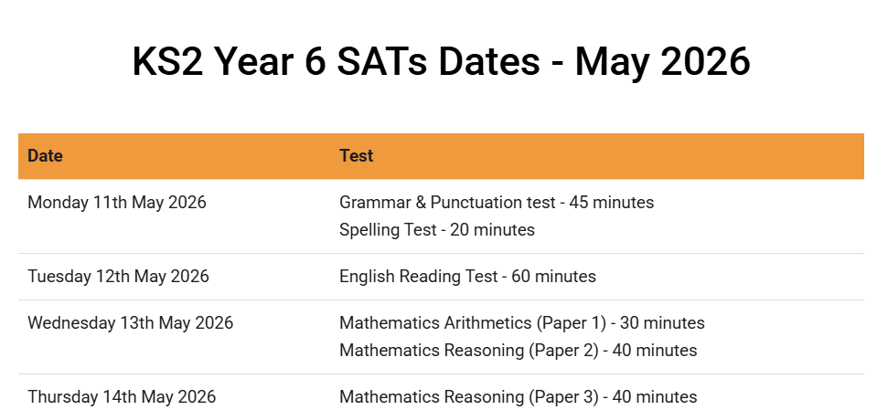

If you have any concerns, please contact me, as your child’s class teacher, in the first instance.

Once again, Welcome back!
Kind regards,

Mr Geary
Class 6 Teacher, Maths, PE and Transition lead

