Inkberrow Primary School
History Curriculum Map
In this document you will find:

- Skill progression for Year 1 – Year 6
- Green skills = ARE expectation for coverage and attainment
- Purple skills = Challenge and working at Greater Depth in the area
- Bright Yellow boxes = National Content and Coverage
- Pale Yellow boxes = key skills for subjects
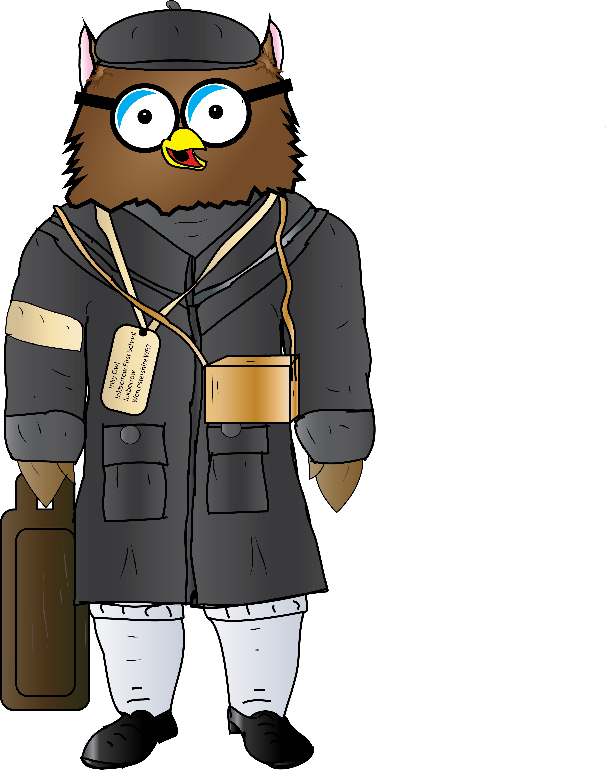
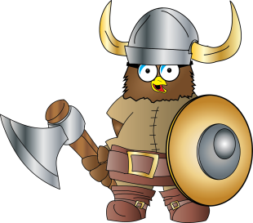History Curriculum Map
National Curriculum Requirements for History at Key Stage 1
Pupils should develop an awareness of the past, using common words and phrases relating to the passing of time. They should know where the people and events they study fit within a chronological framework and identify similarities and differences between ways of life in different periods. They should use a wide vocabulary of everyday historical terms. They should ask and answer questions, choosing and using parts of stories and other sources to show that they know and understand key features of events. They should understand some of the ways in which we find out about the past and identify different ways in which it is represented.
Pupils should be taught about:
- changes within living memory. Where appropriate, these should be used to reveal aspects of change in national life
- events beyond living memory that are significant nationally or globally (e.g. the Great Fire of London, the first aeroplane flight or events commemorated through festivals or anniversaries)
- the lives of significant individuals in the past who have contributed to national and international achievements. Some should be used to compare aspects of life in different periods (e.g. Elizabeth I and Queen Victoria, Christopher Columbus and Neil Armstrong, William Caxton and Tim Berners-Lee, Pieter Bruegel the Elder and LS Lowry, Rosa Parks and Emily Davison, Mary Seacole and/or Florence Nightingale and Edith Cavell)
- significant historical events, people and places in their own locality.

National Curriculum Requirements for History at Key Stage 2
Pupils should continue to develop a chronologically secure knowledge and understanding of British, local and world history, establishing clear narratives within and across the periods they study. They should note connections, contrasts and trends over time and develop the appropriate use of historical terms. They should regularly address and sometimes devise historically valid questions about change, cause, similarity and difference, and significance. They should construct informed responses that involve thoughtful selection and organisation of relevant historical information. They should understand how our knowledge of the past is constructed from a range of sources and that different versions of past events may exist, giving some reasons for this.
In planning to ensure the progression described above through teaching the British, local and world history outlined below, teachers should combine overview and depth studies to help pupils understand both the long arc of development and the complexity of specific aspects of the content.
Pupils should be taught about:
Changes in Britain from the Stone Age to the Iron Age  This could include:  - late Neolithic hunter-gatherers and early farmers, e.g. Skara  Brae  - Bronze Age religion, technology and travel, e.g. Stonehenge  - Iron Age hill forts: tribal kingdoms, farming, art and culture | The Roman Empire and its impact on Britain  This could include:  - Julius Caesar’s attempted invasion in 55-54 BC  - the Roman Empire by AD 42 and the power of its army  - successful invasion by Claudius and conquest, including Hadrian’s Wall  - British resistance, e.g. Boudica  - “Romanisation” of Britain: sites such as Caerwent and the impact of technology, culture and beliefs, including early Christianity
Britain’s settlement by Anglo-Saxons and Scots  This could include:  - Roman withdrawal from Britain in c. AD 410 and the fall of the western Roman Empire  - Scots invasions from Ireland to north Britain (now Scotland)  - Anglo-Saxon invasions, settlements and kingdoms: place names and village life  - Anglo-Saxon art and culture  - Christian conversion – Canterbury, Iona and Lindisfarne | The Viking and Anglo-Saxon struggle for the Kingdom of England to the time of Edward the Confessor  This could include:  - Viking raids and invasion  - resistance by Alfred the Great and Athelstan, first king of England  - further Viking invasions and Danegeld  - Anglo-Saxon laws and justice  - Edward the Confessor and his death in 1066
A local history study  For example:  - a depth study linked to one of the British areas of study listed above  - a study over time tracing how several aspects national history are reflected in the locality (this can go beyond 1066)  - a study of an aspect of history or a site dating from a period beyond 1066 that is significant in the locality | A study of an aspect or theme in British history that extends pupils’ chronological knowledge beyond 1066  For example:  - the changing power of monarchs using case studies such as John, Anne and Victoria  - changes in an aspect of social history, such as crime and punishment from the Anglo-Saxons to the present or leisure and entertainment in the 20th Century  - the legacy of Greek or Roman culture (art, architecture or literature) on later periods in British history, including the present day  - a significant turning point in British history, e.g. the first railways or the Battle of Britain
The achievements of the earliest civilizations – an overview of where and when the first civilizations appeared and a depth study of one of the following: Ancient Sumer; The Indus Valley; Ancient Egypt; The Shang Dynasty of Ancient China. | Ancient Greece – a study of Greek life and achievements and their influence on the western world
A non-European society that provides contrasts with British history - one study chosen from: early Islamic civilization, including a study of Baghdad c. AD 900; Mayan civilization c. AD 900; Benin (West Africa) c. AD 900-1300.

Year 1 | Chronological understanding | Knowledge and interpretation | Historical enquiry
 | Can they put up to three objects in chronological order (recent history)?  Can they use words and phrases like: old, new and a long time ago?  Can they tell me about things that happened when they were little?  Can they recognise that a story that is read to them may have happened a long time ago?  Do they know that some objects belonged to the past?  Can they explain how they have changed since they were born?  Can they put up to five objects/events in chronological order (recent history)?  Can they use words and phrases like: very old, when mummy and daddy were little?  Can they use the words before and after correctly? | Do they appreciate that some famous people have helped our lives be better today?  Do they recognise that we celebrate certain events, such as bonfire night, because of what happened many years ago?  Can they begin to identify the main differences between old and new objects?  Can they identify objects from the past, such as vinyl record?  Can they explain why certain objects were different in the past, e.g. iron, music systems, and televisions?  Can they tell us about an important historical event that happened in the past? | Can they ask and answer questions about old and new objects?  Can they spot old and new things in a picture?  Can they answer questions using an artefact/ photograph provided?  Can they give a plausible explanation about what an object was used for in the past?  Can they answer questions using a range of artefacts/ photographs provided?  Can they find out more about a famous person from the past and carry out some research on him or her?
Year 2 | Chronological understanding | Knowledge and interpretation | Historical enquiry
 | Can they use the words ‘past’ and ‘present’ correctly?  Can they use a range of appropriate words and phrases to describe the past?  Can they sequence a set of events in chronological order and give reasons for their order?  Can they sequence a set of objects in chronological order and give reasons for their order? | Can they recount the life of someone famous from Britain who lived in the past giving attention to what they did earlier and what they did later?  Can they recount some interesting facts from an historical event, such as where the fire of London started?  Can they give examples of things that are different in their life from that of their grandparents when they were young?  Can they give examples of things that are different in their life from that of a long time ago in a specific period of history such as the Victorian times? | Can they find out something about the past by talking to an older person?  Can they answer questions by using a specific source, such as an information book?  Can they research the life of a famous Briton from the past using different resources to help them?  Can they research the life of someone who used to live in their area using the Internet and other sources to find out about them?  Can they say at least two ways they can find out about the past, for example using books and the internet?
Year 3 | Chronological understanding | Knowledge and interpretation | Historical enquiry
 | Can they describe events and periods using the words: BC, AD and decade?  Can they describe events from the past using dates when things happened?  Can they use a timeline within a specific time in history to set out the order things may have happened?  Can they use their mathematical knowledge to work out how long ago events would have happened?  Can they set out on a timeline, within a given period, what special events took place? | Do they appreciate that the early Brits would not have communicated as we do or have eaten as we do?  Can they begin to picture what life would have been like for the early settlers?  Can they suggest why certain events happened as they did in history?  Can they suggest why certain people acted as they did in history?  Do they know that people who lived in the past cooked and travelled differently and used different weapons from ours?  Do they recognise that the lives of wealthy people were very different from those of poor people? | Do they recognise the part that archaeologists have had in helping us understand more about what happened in the past?  Can they use various sources of evidence to answer questions?  Can they use various sources to piece together information about a period in history?  Can they research a specific event from the past?  Can they use their ‘information finding’ skills, in writing, to help them write about historical information?  Can they, through research, identify similarities and differences between given periods in history?  Can they use specific search engines on the Internet to help them find information more rapidly?
Year 4 | Chronological understanding | Knowledge and interpretation | Historical enquiry
 | Can they plot recent history on a timeline using centuries?  Can they place periods of history on a timeline showing periods of time?  Can they describe events and periods using the words: ancient and century?  Can they use their mathematical skills to help them work out the time differences between certain major events in history?  Can they begin to build up a picture of what main events happened in Britain/ the world during different centuries?  Can they use their mathematical skills to round up time differences into centuries and decades? | Can they explain how events from the past have helped shape our lives?  Do they appreciate that wars have happened from a very long time ago and it is often associated with invasion, conquering or religious differences?  Do they appreciate how items found belonging to the past are helping us to build up an accurate picture of how people lived in the past?  Can they recognise that Britain has been invaded by several different groups over time?  Can they begin to appreciate why Britain would have been an important country to have invaded and conquered?  Can they appreciate that war/s would inevitably have brought much distress and bloodshed?  Do they appreciate that the food people ate was different because of the availability of different sources of food?  Can they summarise what Britain may have learnt from other countries and civilizations through time gone by and more recently? | Can they research two versions of an event and say how they differ?  Can they research what it was like for a child in a given period from the past and use photographs and illustrations to present their findings?  Can they give more than one reason to support an historical argument?  Can they communicate knowledge and understanding orally and in writing and offer points of view based upon what they have found out?  Can they independently, or as part of a group, present an aspect they have researched about a given period of history using multi-media skills when doing so?  Can they identify and explain their understanding of propaganda?

Year 5 | Chronological understanding | Knowledge and interpretation | Historical enquiry
 | Can they use dates and historical language in their work?  Can they draw a timeline with different time periods outlined which show different information, such as, periods of history, when famous people lived, etc.?  Can they use their mathematical skills to work exact time scales and differences as need be?  Do they appreciate that some ancient civilizations showed greater advancements than people who lived centuries after them? | Can they describe historical events from the different period/s they are studying/have studied?  Can they make comparisons between historical periods; explaining things that have changed and things which have stayed the same?  Do they appreciate that significant events in history have helped shape the country we have today? | Can they test out a hypothesis in order to answer a question?  Do they appreciate how historical artefacts have helped us understand more about British lives in the present and past?  Can they begin to use more than one source of information to bring together a conclusion about an historical event?
Year 6 | Chronological understanding | Knowledge and interpretation | Historical enquiry
 | Can they say where a period of history fits on a timeline?  Can they place a specific event on a timeline by decade?  Can they place features of historical events and people from past societies and periods in a chronological framework?  Can they create timelines which outline the development of specific features, such as medicine; weaponry; transport, etc. | Can they summarise the main events from a specific period in history, explaining the order in which key events happened?  Can they describe features of historical events and people from past societies and periods they have studied?  Can they recognise and describe differences and similarities/ changes and continuity between different periods of history?  Can they suggest relationships between causes in history?  Can they summarise what Britain may have learnt from other countries and civilizations through time gone by and more recently? | Can they look at two different versions and say how the author may be attempting to persuade or give a specific viewpoint?  Can they describe a key event from Britain’s past using a range of evidence from different sources?  Can they suggest why there may be different interpretations of events?  Can they suggest why certain events, people and changes might be seen as more significant than others?  Can they pose and answer their own historical questions?

