In this document you will find:
- Skill progression for Year 1 – Year 6
- Green skills = ARE expectation for coverage and attainment
- Purple skills = Challenge and working at Greater Depth in the area
- Bright Yellow boxes = National Content and Coverage
- Pale Yellow boxes = key skills for subjects
Geography Curriculum Map
Inkberrow Primary School
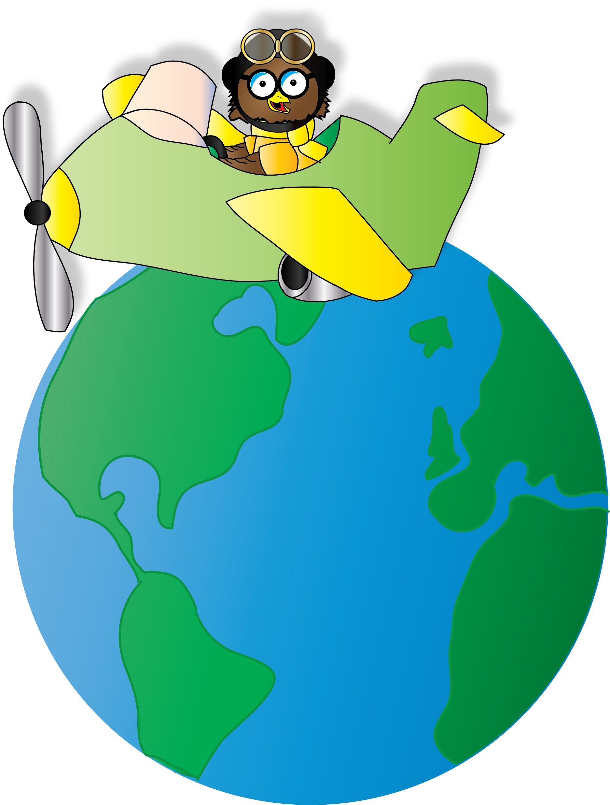

Key Stage 1
Geography Curriculum Map

Pupils should develop knowledge about the world, the United Kingdom and their locality. They should understand basic subject-specific vocabulary relating to human and physical geography and begin to use geographical skills, including first-hand observation, to enhance their locational awareness.

Locational Knowledge
- Name and locate the world’s 7 continents and 5 oceans.
- Name, locate and identify characteristics of the 4 counties and capital cities of the United Kingdom and its surrounding seas.

Place Knowledge
- Understand geographical similarities and differences through studying the human and physical geography of a small area of the United Kingdom and of a small area in a contrasting non-European country.

Human and Physical Geography
- Identify seasonal and daily weather patterns in the United Kingdom and the location of hot and cold areas of the world in relation to the Equator and the North and South Poles.
- Use basic geographical vocabulary to refer to: key physical features, including: beach, cliff, coast, forest, hill, mountain, sea, ocean, river, soil, valley, vegetation, season and weather.
- Use basic geographical vocabulary to refer to: key human features, including: city, town, village, factory, farm, house, office, port, harbour and shop.

Geographical Skills and Fieldwork
- Use world maps, atlases and globes to identify the United Kingdom and its countries, as well as the countries, continents and oceans studied at this key stage.
- Use simple compass directions (North, South, East and West) and locational and directional language [for example, near and far; left and right], to describe the location of features and routes on a map.
- Use aerial photographs and plan perspectives to recognise landmarks and basic human and physical features; devise a simple map; and use and construct basic symbols in a key.
- Use simple fieldwork and observational skills to study the geography of their school and its grounds and the key human and physical features of its surrounding environment.

KS1 | Locational  Knowledge | Place  Knowledge | Human and Physical  Geography | Geographical Skills and Fieldwork
Year 1 | - Can they say what they like about their locality?  - Can they sort things they like and don’t like?  - Can they think of a few good questions to ask about a locality?  - Can they describe a locality using words and pictures?  - Can they identify the four countries making up the United Kingdom?  - Can they name some of the main towns and cities in the United Kingdom?  - Can they point out where the equator, north pole and south pole are on a globe or atlas?  - Can they name a few towns in the south and north of the UK? | - Can they tell someone their address?  - Can they explain the main features of a hot and cold place?  - Can they describe a locality using words and pictures?  - Can they explain how the weather changes with each season?  - Can they name key features associated with a town or village, eg, church, farm, shop, house?  - Can they name key features associated with a town or village, e.g. ‘factory’, ‘detached house’, ‘semi-detached house’, ‘terrace house’? | - Can they answer questions about the weather?  - Can they keep a weather chart?  - Can they answer questions using a weather chart?  - Can they make plausible predictions about what the weather may be like later in the day or tomorrow?  - Can they begin to explain why they would wear different clothes at different times of the year?  - Can they tell something about the people who live in hot and cold places?  - Can they explain what they might wear if they lived in a very hot or a very cold place?  - Can they name different jobs that people living in their area might do? | - Can they answer questions using different resources, such as book, the internet and atlases?  - Can they tell someone their address?  - Can they discuss Aerial photos and plan routes on a map?
Year 2 | - Can they name the continents of the world and find them in an atlas?  - Can they name the world’s oceans and find them in an atlas?  - Can they name the main cities of England, Wales, Scotland and Ireland?  - Can you find where they live on a map of the UK?  - Can they locate hot and cold areas of the world in relation to the equator North and South Pole? | - Can they describe some human features of own locality, such as the jobs people do?  - Can they explain what facilities a town or village might need?  - Can they find out about a locality by using different sources of evidence?  - Can they say what they like and don’t like about their locality and another locality like the seaside?  - Can they describe some places which are not near the school?  - Can they describe a place outside Europe using geographical words? | - Can they label a diagram or photograph using some geographical words?  - Can they describe some of the features associated with an island?  - Can they describe the key features of a place, using words like, beach, coast forest, hill, mountain, ocean and valley? | - Can they use simple compass directions?  - Can they point out the North, South, East and West associated with maps and compass?  - Can they devise a simple map?  - Can they construct basic symbols using a key?  - Can they use simple fieldwork and observational skills to study the geography of the school and the grounds?
Key Stage 2
Pupils should extend their knowledge and understanding beyond the local area to include the United Kingdom and Europe, North and South America. This will include the location and characteristics of a range of the world’s most significant human and physical features. They should develop their use of geographical knowledge, understanding and skills to enhance their locational and place knowledge.
Locational Knowledge
- Locate the world’s countries, using maps to focus on Europe (including the location of Russia) and North and South America, concentrating on their environmental regions, key physical and human characteristics, countries, and major cities.
- Name and locate counties and cities of the United Kingdom, geographical regions and their identifying human and physical characteristics, key topographical features (including hills, mountains, coasts and rivers), and land-use patterns; and understand how some of these aspects have changed over time.
- Identify the position and significance of latitude, longitude, Equator, Northern Hemisphere, Southern Hemisphere, the Tropics of Cancer and Capricorn, Arctic and Antarctic Circle, the Prime/Greenwich Meridian and time zones (including day and night).

Place Knowledge
- Understand geographical similarities and differences through the study of human and physical geography of a region of the United Kingdom, a region in a European country, and a region within North or South America.
Human and Physical Geography
- Describe and understand key aspects of: physical geography, including: climate zones, biomes and vegetation belts, rivers, mountains, volcanoes and earthquakes, and the water cycle.
- Describe and understand key aspects of: human geography, including: types of settlement and land use, economic activity including trade links, and the distribution of natural resources including energy, food, minerals and water.
Geographical Skills and Fieldwork
- Use maps, atlases, globes and digital/computer mapping to locate countries and describe features studied.
- Use the eight points of a compass, four and six-figure grid references, symbols and key (including the use of Ordnance Survey maps) to build their knowledge of the United Kingdom and the wider world.
- Use fieldwork to observe, measure, record and present the human and physical features in the local area using a range of methods, including sketch maps, plans and graphs, and digital technologies.

LKS2 | Locational  Knowledge | Place  Knowledge | Human and Physical  Geography | Geographical Skills and Fieldwork
Year 3 | - Can they identify the position of the Equator and name a number of countries in the Northern Hemisphere and Southern Hemisphere?  - Can they locate and name some of the world’s most famous mountain regions and volcanoes on maps?  - Can they name up to six cities in the UK and locate them on a map?  - Can they locate and name some of the main islands that surround the UK? |  | - Can they describe and understand key aspects of physical geography: including mountains, volcanoes and earthquakes?  - Can they describe how Volcanoes and Earthquakes have an impact on people’s life? | - Can they use the 4 points of a compass and plot NSEW on a map?  - Can they begin to use 4 figure grid references?  - Can they use maps and atlases appropriately by using contents and indexes?  - Can they begin to use some basic OS symbols and keys on a map?  - Can they use correct Geographical words to describe a place and the things that happen there?
Year 4 | - Can they locate the world’s countries using maps?  - Can they name up to six counties in the UK and locate them on a map?  - Can they locate the Tropic of Cancer and the Tropic of Capricorn and discuss its significance?  - Can they locate the Arctic and Antarctic Circle and discuss its significance?  - Can they use an atlas to locate and name the main countries in South America on a map? | - Do they know the difference between the British Isles, Great Britain and the UK?  - Can they explain why a locality has certain human features?  - Are they aware of different weather in different parts of the world? | - Can they explain how the water cycle works?  - Can they begin to recognise the climate of a given country according to its location on a map?  - Can they accurately measure and collect information (e.g. rainfall and temperature)?  - Can they explain how some places are similar and others are different in relation to their human features?  - Can they explain how some places are similar and others are different in relation to their physical features? | - Can they use the 8 points on a compass?  - Can they accurately use 4 figure grid references?  - Can they use maps, atlases and globes to locate countries and describe features studied?  - Can they use graphs and digital technologies to measure and record the human and physical features in the local area?
UKS2 | Locational  Knowledge | Place  Knowledge | Human and Physical  Geography | Geographical Skills and Fieldwork
Year 5 | - Can they name and locate some well-known European countries?  - Can they name and locate the capital cities of neighbouring European countries?  - Can they identify the position and significance of latitude and longitude?  - Can they name the two largest seas around Europe? | - Can they locate the Mediterranean and explain why it is a popular holiday destination?  - Are they aware of different weather in different parts of the world, especially Europe?  - Can they plan a journey to a place in another part of the world, taking account of distance and time? | - Can they explain how the lives of people living in the Mediterranean would be different from their own?  - Can they confidently describe human features in a locality and explain why a locality has these features?  - Can they explain why a place is like it is? | - Can they begin to use 6 figure grid references?  - Can they use maps, atlases, globes and digital/computer mapping to locate countries and describe features studied?  - Can they find possible answers to their own geographical questions?  - Can they collect information about a place and use it in a report?
Year 6  Fieldwork River/Coast  Study | - Can they identify geographical regions in the UK including land-use patters?  - Can they name and locate famous rivers on a map including those in the UK?  - Can they identify the position and significance of the Prime/Greenwich Meridian and time zones (including day and night) and explain how time zones work? | - Can they explain what a place might be like in the future, taking account of issues impacting on human features?  - Can they explain how a location fits into its wider geographical location; with reference to human and economical features?  - Can they explain how a locality has changed over time with reference to human features?  - Can they name the areas of origin of the main ethnic groups in the UK and in their school?  - Can they suggest different ways that a locality could be changed and improved? | - Can they describe and understand key aspects of physical geography including rivers and coasts?  - Can they just why water is such a valuable commodity and how its availability varies across the world?  - Can they explain why people are attracted to live by rivers and coasts and explain why many cities of the world are situated by rivers/coasts?  - Can they explain why people are attracted to live in cities?  - Can they explain why people may choose to live in a village rather than a city?  - Can they explain how some places are similar and others are different in relation to their human features?  - Can they report on ways in which humans have both improved and damaged the environment? | - Can they accurately use 6 figure grid references?  - Can they explain scale and use maps with a range of scales?  - Can they use symbols and keys (including the use of ordnance survey maps) to build their knowledge of the UK and the wider world?  - Can they use fieldwork to observe, measure, record and present the human and physical features in the local area using a range of methods, including sketch maps, plans and graphs and digital technologies?

