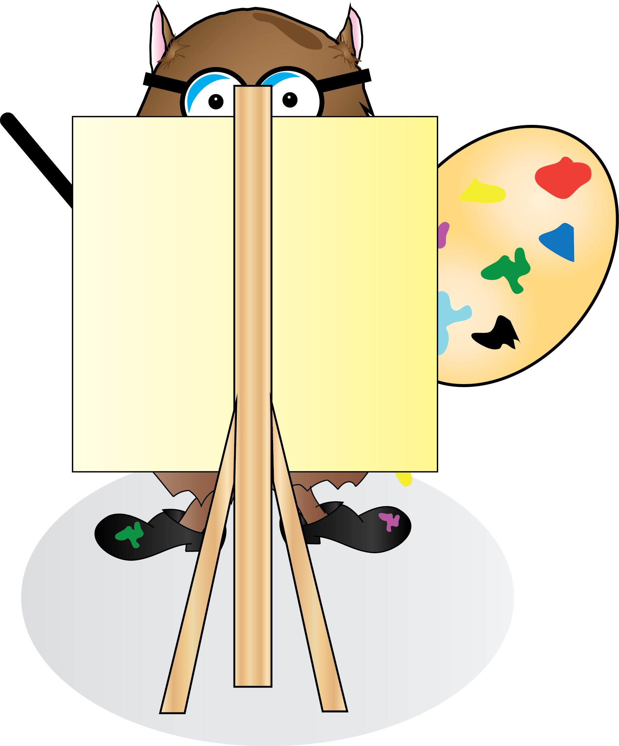

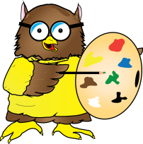Art Curriculum Map
Inkberrow Primary School
In this document you will find:

- Skill progression for Year 1 – Year 6
- Green skills = ARE expectation for coverage and attainment
- Purple skills = Challenge and working at Greater Depth in the area
- Bright Yellow boxes = National Content and Coverage
- Pale Yellow boxes = key skills for subjects
Art
Curriculum Map

National Curriculum Requirements of Art and Design at Key Stage 1
Pupils should be taught creativity in art, craft and design by:

- Using a range of materials creatively to design and make products
- using drawing, painting and sculpture to develop and share their ideas, experiences and imagination
- developing a wider range of art and design techniques in using colour, pattern, texture, line, shape, form and space
- learning about the work of a range of artists, craft makers and designers, describing the differences and similarities between different practices and disciplines, and making links to their own work.

National Curriculum Requirements of Art and Design at Key Stage 2
Pupils should be taught to develop their techniques, including their control and their use of materials, with experimentation and an increasing awareness of different kinds of art, craft and design.

Pupils should be taught:

- to create sketch books to record their observations and use them to review and revisit ideas

- to improve their mastery of art and design techniques, including drawing, painting and sculpture with a range of materials (e.g. pencil, charcoal, paint, clay)

- about the greatest artists, architects and designers in history.

Year 1 Drawing | Painting | Printing | Textiles
Can they draw using pencil and crayons?  Can they draw lines of different shapes and thickness, using 2 different grades of pencil? | Can they choose to use thick and thin brushes as appropriate?  Can they paint a picture of something they can see?  Can they name the primary and secondary colours? | Can they print with sponges, vegetables and fruit?  Can they print onto paper and textile?  Can they create a repeating pattern? | Can they sort threads and fabrics?  Can they group fabrics and threads by colour and texture?  Can they weave with fabric and thread?
Year 2 Drawing | Painting | Printing | Sketch books
Can they use three different grades of pencil in their drawing (4B, 8B, HB)  Can they use charcoal, pencil and pastels?  Can they create different tones using light and dark? | Can they mix paint to create all the secondary colours?  Can they make tints by adding white?  Can they make tones by adding black? | Can they create a print using pressing, rolling, rubbing and stamping?  Can they create a print like a designer? | Can they begin to demonstrate their ideas through photographs and in their sketches?  Can they make notes by their sketches to how they have changed their work?
Year 3 Drawing | Painting | Printing | Sketch books
Can they show facial expressions in their drawings?  Can they use their sketches to produce a final piece of work?  Can they write an explanation of their sketch in notes?  Can they select and use different grades of pencil shade, to show different tones and texture? | Can they predict with accuracy the colours that they mix?  Do they know where each of the primary and secondary colours sits on the colour wheel?  Can they create a background using a wash?  Can they use a range of brushes to create different effects? | Can they make a printing block?  Can they make a 2 colour print? | Can they use their sketch books to express feelings about a subject and to describe likes and dislikes?  Can they make notes in their sketch books about techniques used by artists?  Can they suggest improvements to their work by keeping notes in their sketch books?
Year 4 Drawing | Painting | Printing | Sketch books
Can they begin to show facial expressions and body language in their sketches?  Can they identify and draw simple objects, and use marks and lines to produce texture?  Can they organise line, tone, shape and colour to represent figures and forms in movement?  Can they explain why they have chosen specific materials to draw with? | Can they create all the colours they need?  Can they create mood in their paintings?  Do they successfully use shading to create mood and feeling? | Can they print using at least four colours?  Can they create an accurate print design?  Can they print onto different materials? | Can they use their sketch books to express their feelings about various subjects and outline likes and dislikes?  Can they use their sketch books to adapt and improve their original ideas?  Can they keep notes about the purpose of their work in their sketch books?
Year 5 Drawing | Painting | Printing | Sketch books
Can they identify and draw simple objects, and use marks and lines to produce texture?  Do they successfully use shading to create mood and feeling?  Can they organise line, tone, shape and colour to represent figures and forms in movement?  Can they show reflections?  Can they explain why they have chosen specific materials to draw with? | Can they create a range of moods in their paintings?  Can they express their emotions accurately through their painting and sketches? | Can they print using a number of colours?  Can they create an accurate print design that meets a given criteria?  Can they print onto different materials? | Do they keep notes in their sketch books as to how they might develop their work further?  Do they use their sketch books to compare and discuss ideas with others?
Year 6 Drawing | Painting | Printing | Sketch books
Do their sketches communicate emotions and a sense of self with accuracy and imagination?  Can they explain why they have combined different tools to create their drawings?  Can they explain why they have chosen specific drawing techniques? | Can they explain what their own style is?  Can they use a wide range of techniques in their work?  Can they explain why they have chosen specific painting techniques? | Can they overprint using different colours?  Do they look very carefully at the methods they use and make decisions about the effectiveness of their printing methods? | Do their sketch books contain detailed notes, and quotes explaining about items?  Do they compare their methods to those of others and keep notes in their sketch books?  Do they combine graphics and text based research of commercial design, for example magazines etc., to influence the layout of their sketch books.  Do they adapt and refine their work to reflect its meaning and purpose, keeping notes and annotations in their sketch books?

Year 1 3D/Textiles | Collage | Use of IT | Knowledge
Can they add texture by using tools?  Can they make different kinds of shapes?  Can they cut, roll and coil materials such as clay, dough or plasticine? | Can they cut and tear paper and card for their collages?  Can they gather and sort the materials they will need? | Can they use a simple painting program to create a picture?  Can they use tools like fill and brushes in a painting package?  Can they go back and change their picture? | Can they describe what they can see and like in the work of another artist/craft maker/designer?  Can they ask sensible questions about a piece of art?
Year 2 3D/Textiles | Collage | Use of IT | Knowledge
Can they make a clay pot?  Can they join two finger pots together?  Can they join fabric using glue?  Can they sew fabrics together? | Can they create individual and group collages?  Can they use different kinds of materials on their collage and explain why they have chosen them? | Can they create a picture independently?  Can they use simple IT mark-making tools, e.g. brush and pen tools?  Can they edit their own work? | Can they say how other artists have used colour, pattern and shape?  Can they create a piece of work in response to another artist’s work?
Year 3 3D/Textiles | Collage | Use of IT | Knowledge
Can they add onto their work to create texture and shape?  Can they use more than one type of stitch?  Can they join fabric together?  Can they use sewing to add detail to a piece of work?  Can they add texture to a piece of work? | Can they cut accurately?  Can they overlap materials?  Can they experiment using different colours? | Can they use the printed images they take with a digital camera and combine them with other media to produce art work?  Can they use the web to research an artists or style of art? | Can they compare the work of different artists?  Can they explore work from other cultures?  Can they explore work from other periods of time?  Are they beginning to understand the viewpoints of others by looking at images of people and understand how they are feeling and what the artist is trying to express in their work?
Year 4 3D/Textiles | Collage | Use of IT | Knowledge
Can they begin to sculpt clay and other mouldable materials?  Can they use early textile and sewing skills as part of a project?  Can they create pop ups? | Can they use mosaic?  Can they combine visual and tactile qualities? | Can they create a piece of art work which includes the integration of digital images they have taken?  Can they combine graphics and text based on their research? | Can they experiment with different styles which artists have used?  Can they explain art from other periods of history?
Year 5 3D/Textiles | Collage | Use of IT | Knowledge
Do they experiment with and combine materials and processes to design and make 3D form?  Can they sculpt clay and other mouldable materials?  Can they use textile and sewing skills as part of a project, e.g. hanging, textile book, etc.? This could include running stitch, cross stitch, backstitch, appliqué and/or embroidery. | Can they use ceramic mosaic to produce a piece of art?  Can they combine visual and tactile qualities to express mood and emotion? | Can they create a piece of art work which includes the integration of digital images they have taken?  Can they combine graphics and text based on their research?  Can they scan images and take digital photos, and use software to alter them, adapt them and create work with meaning.  Can they create digital images with animation, video and sound to communicate their ideas. | Can they experiment with different styles which artists have used?  Do they learn about the work of others by looking at their work in books, the Internet, visits to galleries and other sources of information?
Year 6 3D/Textiles | Collage | Use of IT | Knowledge
Can they create models on a range of scales?  Can they create work which is open to interpretation by the audience?  Can they include both visual and tactile elements in their work? | Can they justify the materials they have chosen?  Can they combine pattern, tone and shape? | Do they use software packages to create pieces of digital art to design?  Can they create a piece of art which can be used as part of a wider presentation? | Can they make a record about the styles and qualities in their work?  Can they say what their work is influenced by?  Can they include technical aspects in their work, e.g. architectural design?

