INKBERROW PRIMARY SCHOOL

Love to learn, learn to care

We aspire for all our children to become confident, secure, caring individuals who achieve personal success and develop a love of learning.

Marking Policy



Written By | Glenn Duggan-Seville
Reviewed By/On | C&Q Committee on 22/04/21
Approved By/On | IPS LGB on 10/05/21
Next Review Required | Summer Term 2025

Rationale
Improving learning through effective assessment is aided by the provision of effective feedback to pupils who need to be able to assess themselves and understand how to improve. The marking of pupils’ work is therefore an integral part of teacher assessment and pupil progress.
The purpose of feedback and assessment
- To inform the teacher of a child’s attainment and thereby inform future planning
- To inform the children of how well they have done and what they need to do next
- To motivate a child through celebrating success
Principles
- there is a consistent and manageable method of feedback, assessment and pupil response throughout the school
- work is assessed promptly and feedback given as close as possible to the time of the work completed, including in the lesson
- all adults working with the children are involved in giving feedback
- children are given opportunities to respond to feedback and to make improvements to their work
- clear strategies for improvement are given
- feedback and assessment are used to inform future planning and target setting
Different forms of feedback
At Inkberrow Primary School, the marking and feedback of work is carried out under five main categories. These allow staff to choose the most appropriate method for the children to make the most progress within and across a series of lessons.
These categories are:
Live feedback within a lesson
Small-group and one-to-one conferencing
Distance written feedback after a lesson
Whole class feedback
Self and peer-assessment
Staff are trained to apply these formats in different contexts and to give children variety in the way the teacher / pupil feedback develops.
Below, each of these categories are explained in more detail:
Live feedback within a lesson
- live marking allows a teacher to check that each child has the correct level of challenge: misconceptions can be identified and addressed, small errors corrected and additional stretch can be given where appropriate
- Live marking is time-efficient and reduces the need for distance marking at the end of the day. This in turn frees up time to plan for the next day
- Live marking can be written or verbal
- If a child has needed help with within a lesson, the adult giving the help will indicate this by initialling the work. This will support the teacher’s summative assessment at the end of each term
- Where verbal feedback has been given, this is recorded in children’s books, either by the adult (VF: Finger Spaces), a Teacher / TA assisted stamper or a pre-printed sticker (I spoke to my teacher and we agreed that…)
Small-group and one-to-one conferencing
- A conversation with the child or a group of children about their work can be more effective than written marking as both adults and children develop an unambiguous shared understanding of the next steps
- Conferencing sessions are recorded in the children’s books in the same way as in live verbal feedback (see above)
Distance written feedback
- When immediate feedback cannot be given, work is assessed later to inform future planning and provide feedback to children
- Teachers exercise professional judgement about the amount of written marking that is required; this varies according to age group, subject or task
- Lengthy written feedback is not a proxy for effective feedback
Whole class marking
- This works when similar feedback can be given to the whole class: a common misconception or shared next step
- Whole class feedback is also helpful to model the feedback process to support self-assessment and peer-assessment. Marking one piece of work as a class / group also teaches particular points at the same time. Another strategy is to sensitively compare two pieces of the same written task and discuss their differences
- After this, children mark against the check list (written or oral) of requirements
Self-marking
- Children mark their own work in purple pen (editing) and have opportunities to do this throughout the lesson
- Children are given answer sheets or use success criteria / Every Time We Write / SWEETP2C to ensure accuracy of marking
- The work will be stamped / initialled to show the work has been self-assessed
- When work is self-marked, teachers will look at all the books to check for accuracy and plan next steps for individuals or groups of children
Peer-marking
- Peer-marking will involve the children taking on the role of author / editor. Authors hold the control of the Purple Pen and should be the only children to write in their books This is a collaborative editing process where editors should advise on the improvements needed
- Children are given answer sheets or use success criteria / Every Time We Write / SWEETP2C to ensure accuracy of marking
- The work will be stamped / initialled to show the work has been peer-assessed
- When peer-marked, the teacher will look at the books and check for accuracy and plan next steps for individuals or groups of children
Staff Well-being and workload
To support staff managing the amount of feedback given to children, they will use a variety of the methods above across a day, week and term.
Foundation Subjects
The marking of foundation subjects will be ‘light-touch’. The techniques above can be used to support this. The Learning Objective/Target (LO/T) needs to be highlighted in green if achieved.
If this is not achieved, this should be highlighted in pink, with a follow up target – this could be Verbal Feedback (VF) or conferencing.

Appendix 1 – Marking Procedures

Wrens  Reception | - Green highlighter used to underline if child has independently completed a word  - Green highlighter used as a ‘WOW’ pen – indicator of good example of success criteria (independently)  - Pink highlighter used as next step or areas to improve  - Dotted pink vertical line used to denote where space should be between words  - Pink ^ used to show word or full stop missing in writing  - Smiley face/stamp used to denote verbal feedback given  - VF – Verbal Feedback
Robins  Year 1 | - Highlighter used as a ‘WOW’ pen / green smiley face to indicate good examples of success criteria  - Wavy pink/red line or red Sad Face used to underline spelling error  - Words written underneath to be copied out 3 x and learnt/added to word book  - Dotted vertical pink/red line used to denote where space should be between words  - * to denote excellent work – put a stamp or sticker on their class achievement card  - Red dot used to denote incorrect calculation  - Green tick used to denote correct calculations • VF used to denote verbal feedback given  - 1:1 denotes needed support  - Whole Class Mark will use the symbol WCM
Blackbirds  Year 2 | - Self-Assessment Grids linked to LO for pupil and teacher to complete  - Green highlighter used as ‘WOW’ pen against success criteria and may also indicate other positive feedback  - Red/pink pen to indicate errors / areas to improve  - Pink/red wavy line to indicate that word/sentence does not make sense/could be improved  - ^ used to show something is missing  - Dot used to denote incorrect calculation  - C to indicate pupil is expected to correct the error either beside or underneath the error  - Tick used to denote correct calculations  - Sp to indicate spelling mistake  - T – indicate something they can target  - VF used to denote verbal feedback given  - Teacher stamps used to indicate support / greater depth of understanding  - Whole Class Mark will use the symbol WCM

Woodpeckers  Year 3 | - Green highlighter used as ‘WOW’ pen against success criteria and may also indicate other positive feedback  - Green highlighter used to highlight achievement on LO / T – particularly in maths  - Red/pink pen as errors / areas to improve  - ^ used to show something is missing  - CL, P and Sp in margin to denote errors in capital letters, punctuation and spellings  - Red dot used to denote incorrect calculation  - Green tick used to denote correct recording  - Smiley face – something I am really pleased with  - VF used to denote verbal feedback given  - Teacher Stamp used to show support given for task  - Whole Class Mark will use the symbol WCM  - Conferencing - I spoke to my teacher and we agreed that… sticker
Swans  Year 4 | - Green highlighter used to highlight achievement on LO / T – particularly in maths  - Green pen used as ‘WOW’ pen against success criteria and may indicate other positive features  • Red/pink pen as errors / areas to improve  - Smiley face – something I’m really pleased with  • CL, P and Sp in margin to denote errors in capital letters, punctuation and spelling  - ^ used to show word missing in writing  - Red dot used to denote incorrect calculation  - Green tick used to denote correct recordings  - VF used to denote verbal feedback given  - Teacher Stamp used to show support given for task  - Whole Class Mark will use the symbol WCM  - Conferencing - I spoke to my teacher and we agreed that… sticker
Kestrels  Year 5 | - Green highlighter used to highlight achievement on LO / T – particularly in maths  - Green pen used as ‘WOW’ pen against success criteria and may indicate other positive features  • Red/pink pen as errors / areas to improve  - Smiley face – something I’m really pleased with  • CL, P, T and Sp in margin to denote errors in capital letters, punctuation, tense and spelling  - ^ used to show word missing in writing  - Red dot used to denote incorrect calculation  - Green tick used to denote correct recordings  - VF used to denote verbal feedback given  - Teacher Stamp used to show support given for task  - Whole Class Mark will use the symbol WCM  - Conferencing - I spoke to my teacher and we agreed that… sticker
Owls  Year 6 | - Green highlighter used to highlight achievement on LO / T – particularly in maths  - Green pen used as ‘WOW’ pen against success criteria and may indicate other positive features  • Red/pink pen as errors / areas to improve  - Smiley face – something I’m really pleased with  • CL, P, T and Sp in margin to denote errors in capital letters, punctuation. tense and spelling  - ^ used to show word missing in writing  - Red dot used to denote incorrect calculation  - Green tick used to denote correct recordings  - VF used to denote verbal feedback given  - Teacher Stamp used to show support given for task  - Whole Class Mark will use the symbol WCM  - Conferencing - I spoke to my teacher and we agreed that… sticker

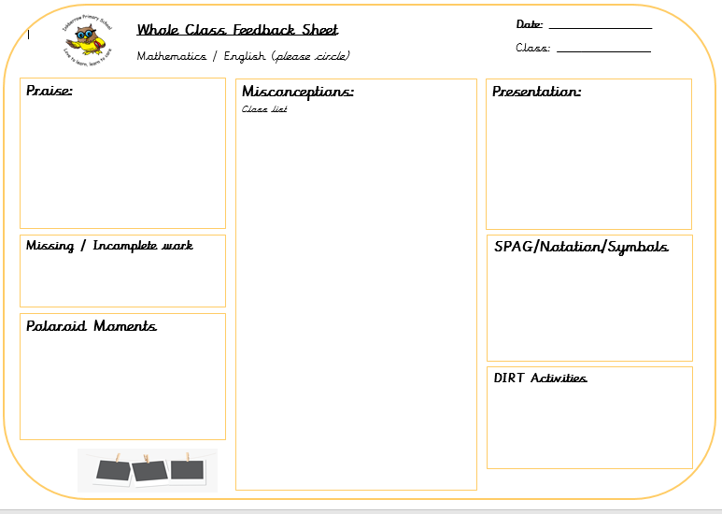
Appendix 2 – Whole Class Marking Sheet

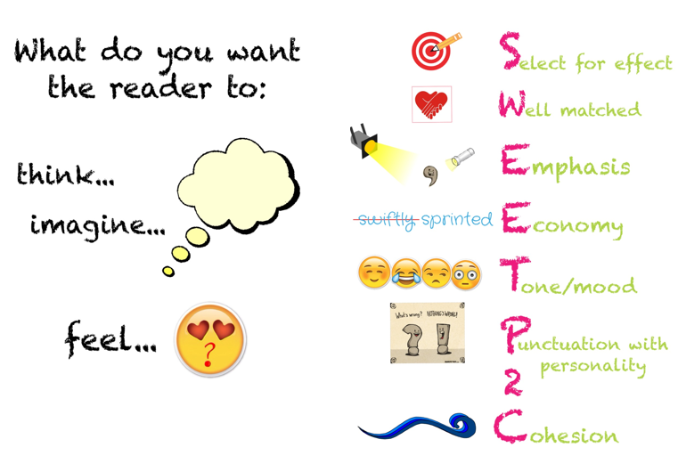
Appendix 3 – SWEETP2C

