What do the INKY values look like?
Value | Reception | Years 1 and 2 | Years 3 & 4 | Years 5 & 6
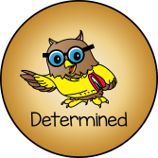 | -Ask my teacher to help me  -finish what I have started  -Keep trying! | -Try again with the help of others  -Try to carry on even if I get upset  -Keep going when I enjoy an activity  -Try to reach my goals | -Find an alternative way if the first attempt does not work  -Bounce-back after a disappointment  -Show an ability to stick to an activity  -Find solutions when I am in the problem pit | -Reflect on my failures and use these to bounce-back and move forward  -Set my own targets and see possibilities and opportunities to challenge myself  -Stick to an activity even in the most challenging of circumstances
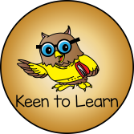 | -Sit on the carpet ready  -Answer questions my teacher asks  -Try lots of activities in the classroom, without an adult | -Be ready!  -Put my hand up to give answers  -Show enthusiasm for learning  -Positive attitude to my learning | -Ask questions to further my learning and understanding  -Show good participation in activities  -Refocus after a distraction and complete tasks  -Use all my learning time will in all lessons | -Push myself in areas that are not necessarily enjoyable to me  -Ask challenging questions and be eager to find out the answers  -Show independent learning in topics outside of school  -Challenge others appropriately
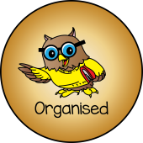 | -Tidy up areas when I have finished  -Put my things in the right place  -Use the right tools to complete a job | -Get my equipment ready  -Support others to get the job done  -Work as a team  -Do extra on my own | -Have the correct equipment ready for an activity  -Use time effectively to suit the activity  -Set my learning out correctly and present it to my highest standards | -Take responsibility for learning and complete all my tasks on time  -Take a leading role in team challenges and tasks  -Organise events that impact on others
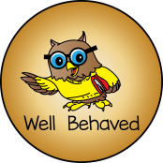 | -Walk around the school and classroom nicely  -Be polite and share  -Play nicely with others  -Take turns and wait | -Follow the rules of the classroom  -Show awareness of someone who is talking  -Use good manners  -Set a good example to others | -Think of the effect of behaviour on others before acting  -Understand other’s points of view  -Be aware of how my behaviour impacts on others  -Treat other’s with respect and model all of the INKY values | -Change my behaviour to suit different situations  -Be aware of my position as a role model to others  -Model the correct behaviour to support others  -Lead by example
 | -Stay in an area until my time is up  -Listen when someone is talking to me | -Sometimes, I will work on my own  -Stay on an activity until I finish it  -Use good listening skills  -Finish the job / task in front of me | -Remain on a task until the end  -Choose appropriate resources to help myself  -Develop my skills of independence  -Use my time well to get the job done | -Effectively tune-out distractions  -Work on my own for the set amount of time  -Choose when it is more effective to learn independently  -Be an effective team player and play the role within in it
Autumn 1 Autumn 2 Spring Summer 1 Summer 2

