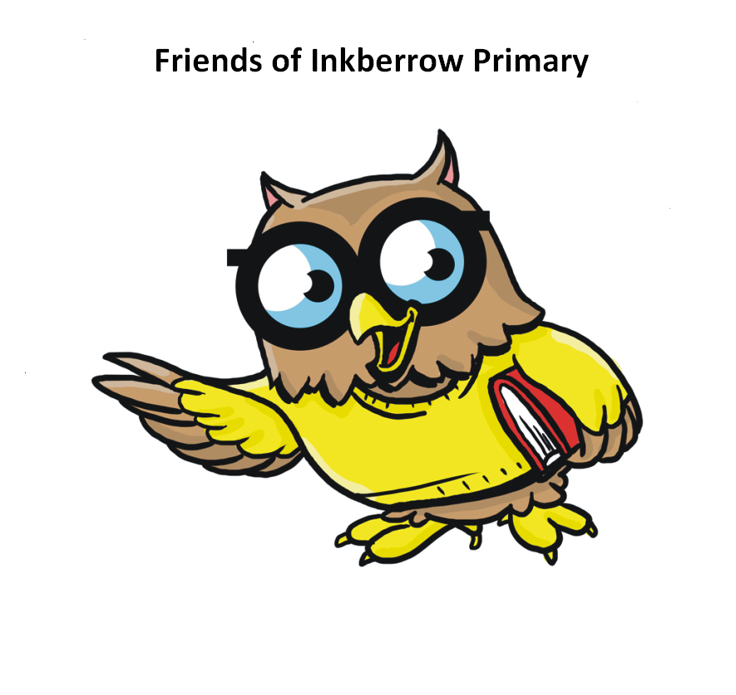
Friends of Inkberrow Primary
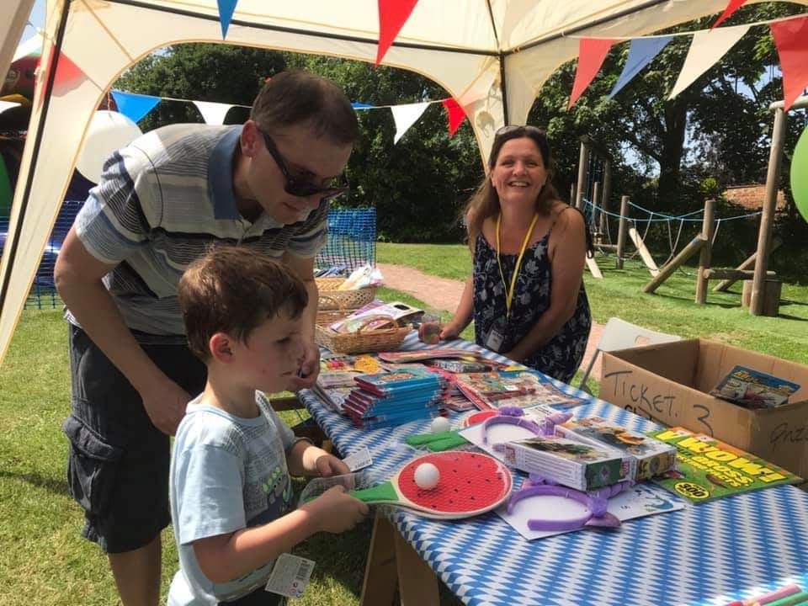
The Friends of Inkberrow Primary (FOIP) group is the school’s Parent Teacher Association (PTA). Having a Friends Association means that anyone that wishes to support the school whether they are parents, grandparents, staff or members of the wider community can join us.
We exist to support the school community and to make the experience of school that bit extra special either through social events or the educational materials and playground equipment that our fundraising provides. Our recent fundraising has meant that the school has been able to buy a media and sound system for the hall, a one-mile running track, garden furniture, laptops, maths resources, items for lunchtime play activities and books.
Some of our team have specific roles as officers and they form the FOIP committee but we always need other active members. We have meetings that take place at school, at each other’s houses during the day and sometimes in a local pub in the evening. We also now have the obligatory WhatsApp group so everyone feels connected whether or not they attended the latest meeting.
We have a regular slot in the school’s weekly newsletter which is emailed to parents and carers and will keep you up to date with our latest activities, and there will be requests over the course of the year for stuff like donations for tombola prizes and for extra help at events. We particularly need this at our biggest event of the year, the summer fete. Of course, the main thing we hope you will do is attend the events and enjoy them with friends and family!
You will find details of our events via the school website and also on our Facebook page (https://www.facebook.com/FriendsofInkberrowPrimary). If you would like to be involved complete the form below and return it to school so we can get in touch with you otherwise look out for details of meetings being advertised, email us using the address below or message us via our Facebook page.
Please do come and join us and have fun helping the school.
Karen Uppal and all the FOIFS committee
friendsofinkberrowprimary@gmail.com
Yes I would love to know more about how I can help FOIP support the school
Name:
Email address:
Skills I might bring to FOIP (e.g marketing, accounting)

