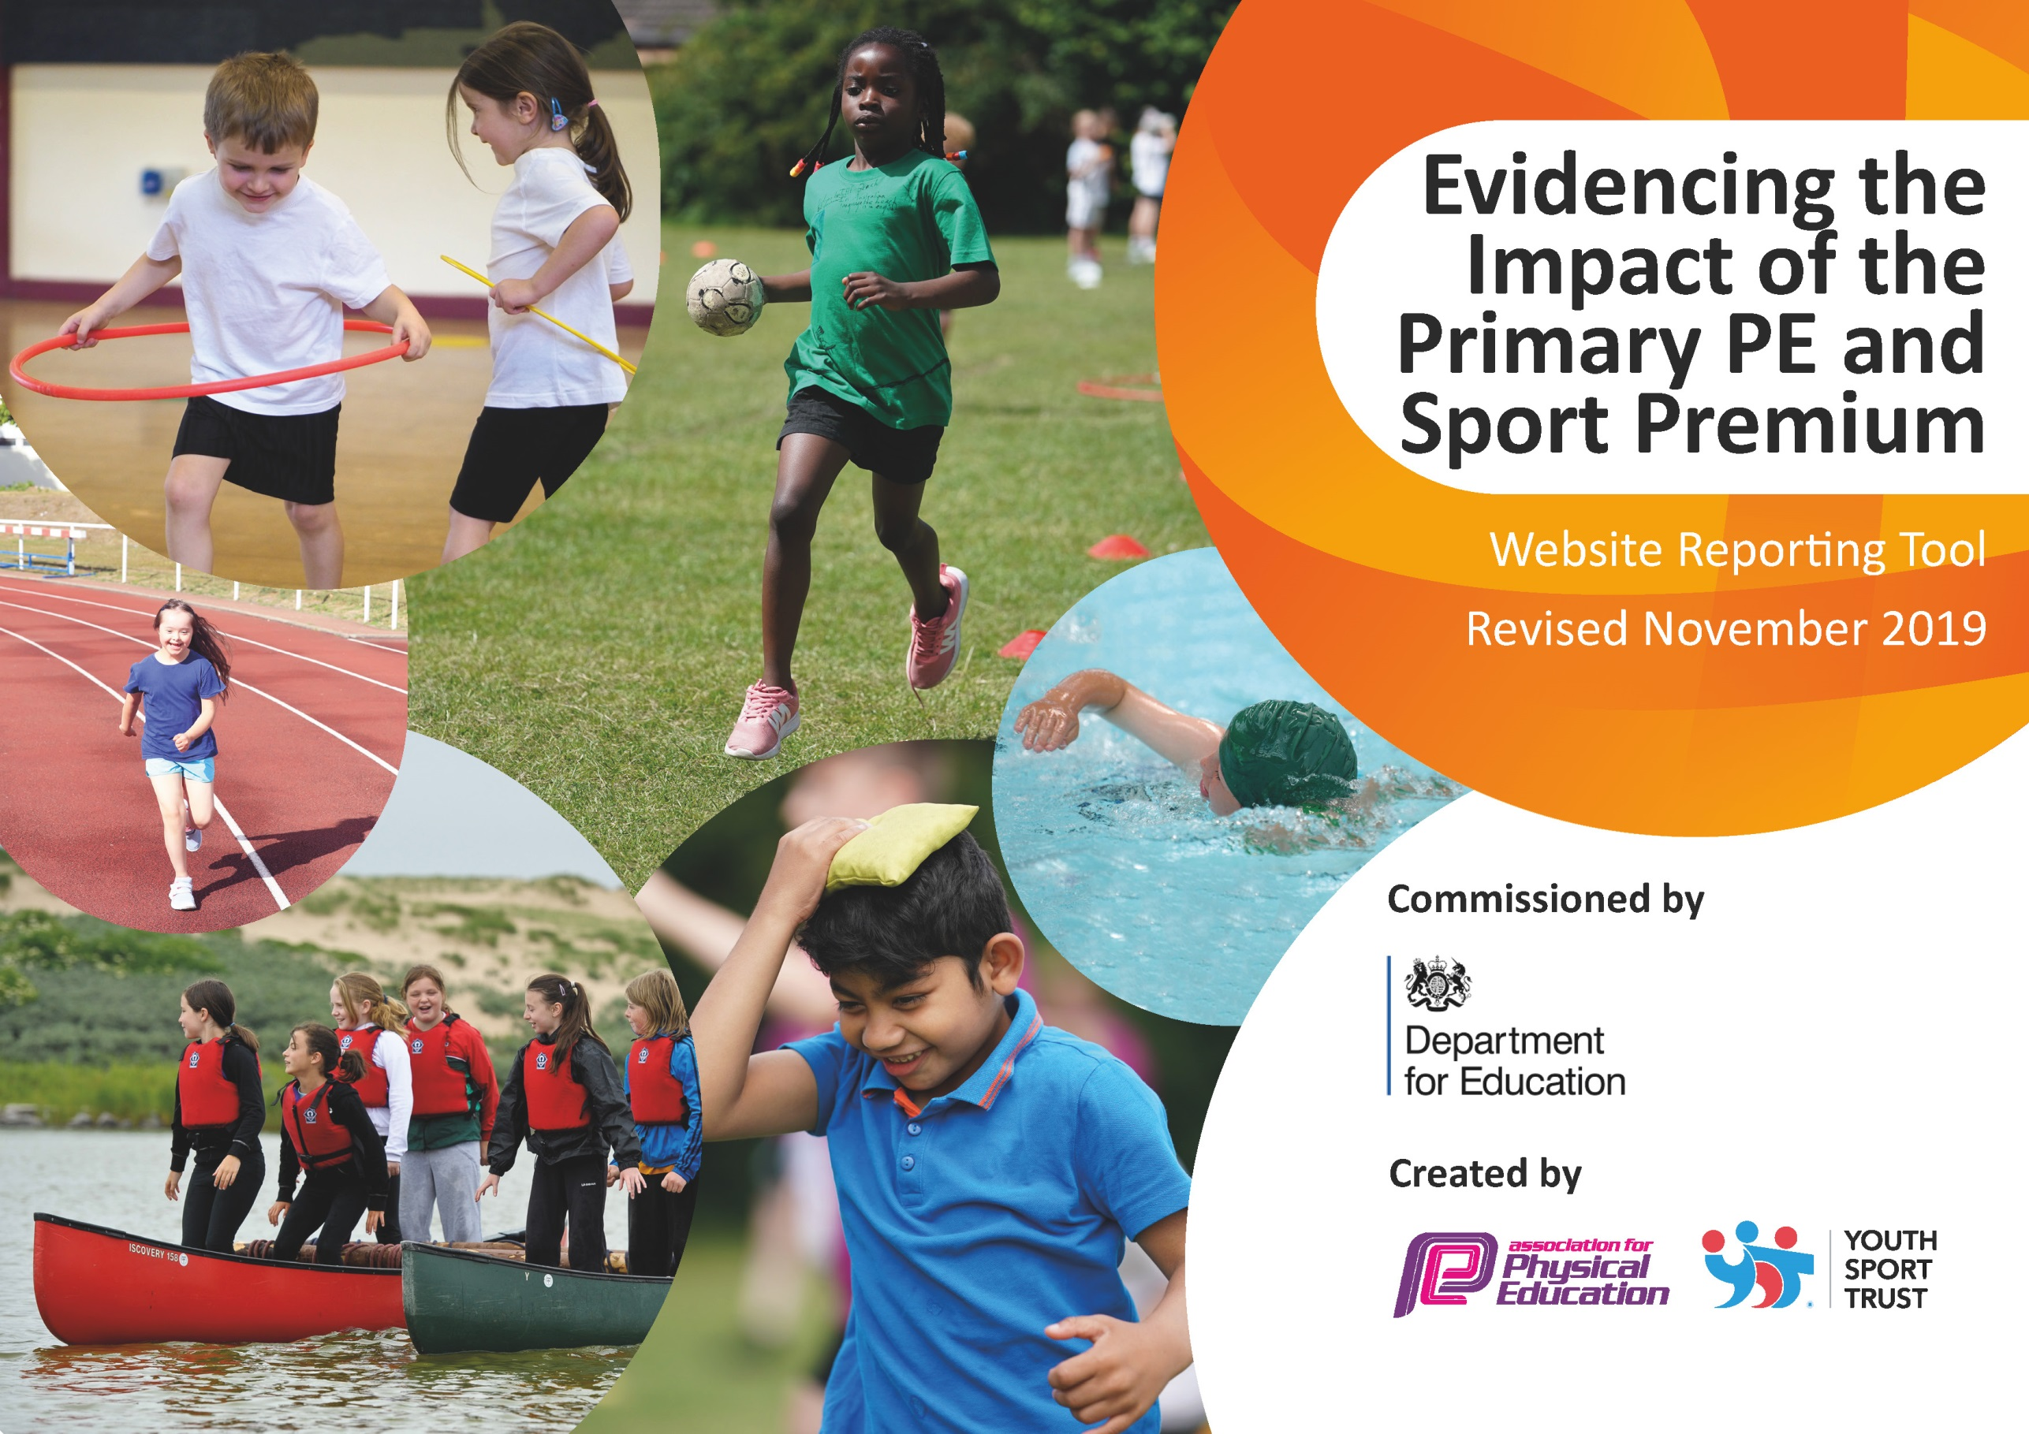
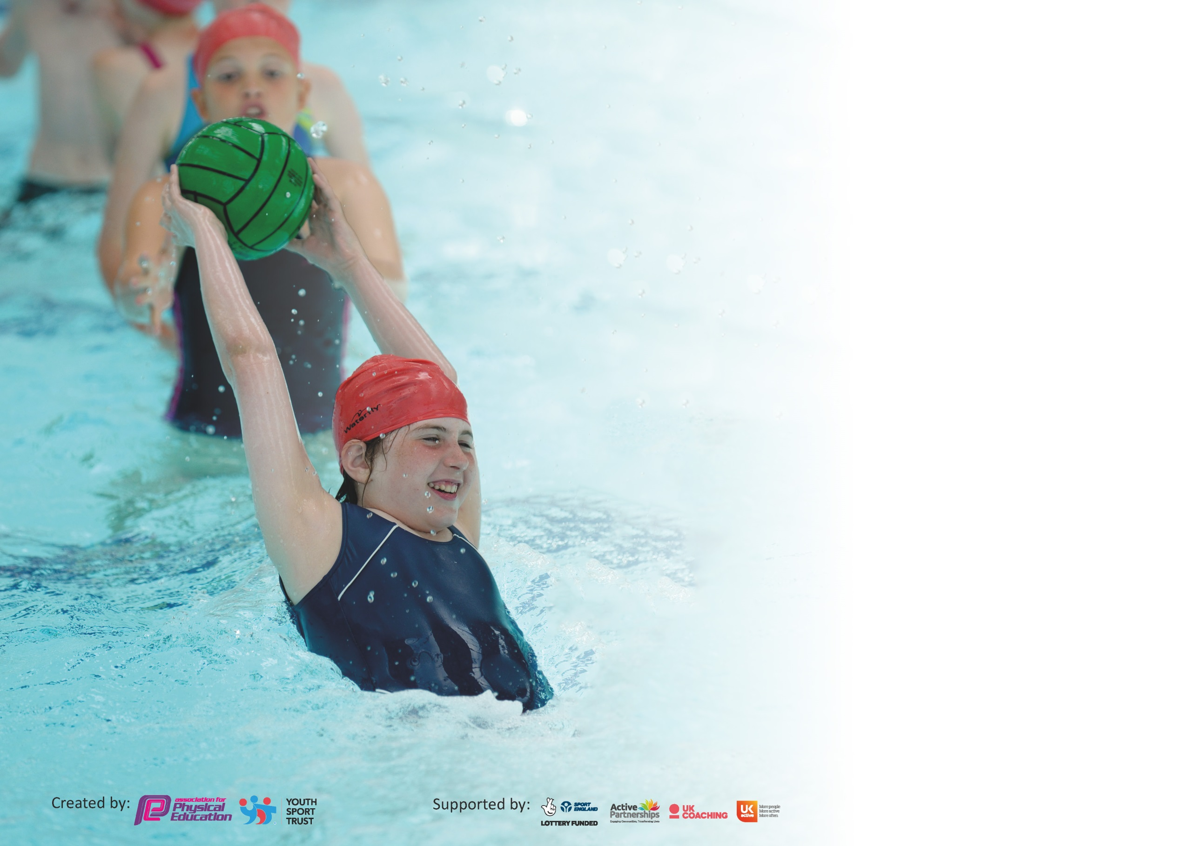

It is important that your grant is used effectively and based on school need. The Education Inspection Framework (Ofsted 2019 p64) makes clear there will be a focus on ‘whether leaders and those responsible for governors all understand their respective roles and perform these in a way that enhances the effectiveness of the school’.

Under the Quality of Education criteria (p41) inspectors consider the extent to which schools can articulate their curriculum (INTENT), construct their curriculum (IMPLEMENTATION) and demonstrate the outcomes which result (IMPACT).

To assist schools with common transferable language this template has been developed to utilise the same three headings which should make your plans easily transferable between working documents.

Schools must use the funding to make additional and sustainable improvements to the quality of Physical Education, School Sport and Physical Activity (PESSPA) they offer. This means that you should
use the Primary PE and Sport Premium to:

- Develop or add to the PESSPA activities that your school already offer
- Build capacity and capability within the school to ensure that improvements made now will benefit pupils joining the school in future years

Please visit gov.uk for the revised DfE guidance including the 5 key indicators across which schools should demonstrate an improvement. This document will help you to review your provision and to report your spend. DfE encourages schools to use this template as an effective way of meeting the reporting requirements of the Primary PE and Sport Premium.

We recommend you start by reflecting on the impact of current provision and reviewing the previous spend.

Schools are required to publish details of how they spend this funding as well as on the impact it has on pupils’ PE and sport participation and attainment by the end of the summer term or by 31st July 2020 at the latest.

We recommend regularly updating the table and publishing it on your website throughout the year. This evidences your ongoing self-evaluation of how you are using the funding to secure maximum, sustainable impact. Final copy must be posted on your website by the end of the academic year and no later than the 31st July 2020. To see an example of how to complete the table please click HERE.

Support for review and reflection - considering the 5 key indicators from DfE, what development needs are a priority for your setting and your pupils now and why? Use the space below to reflect on previous spend and key achievements and areas for development.

Key achievements to date until July 2019: | Areas for further improvement and baseline evidence of need:
High level of pupil participation in lessons and extra-curricular activities | To promote active break times and lunchtimes  To have access to competition outside of school teams  To provide CPD for staff in the core teaching of Physical Education  To give access to physical activity in other lessons  Total Spend: £17,184.50

Meeting national curriculum requirements for swimming and water safety.
What percentage of your current Year 6 cohort swim competently, confidently and proficiently over a distance of at least 25 metres?  N.B. Even though your pupils may swim in another year please report on their attainment on leaving  primary school at the end of the summer term 2020. | NA – No current year 6
What percentage of your current Year 6 cohort use a range of strokes effectively [for example, front crawl, backstroke and breaststroke]? | NA – No current year 6
What percentage of your current Year 6 cohort perform safe self-rescue in different water-based situations? | NA – No current year 6
Schools can choose to use the Primary PE and Sport Premium to provide additional provision for swimming but this must be for activity over and above the national curriculum requirements. Have you used it in this way? | NA – No current year 6

Action Plan and Budget Tracking
Capture your intended annual spend against the 5 key indicators. Clarify the success criteria and evidence of impact that you intend to measure to evaluate for pupils today and for the future.

Academic Year: 2019/2020 | Total fund allocated: £17,300 | Date Updated: February 2020
Key indicator 1: The engagement of all pupils in regular physical activity – Chief Medical Officer guidelines recommend that primary school pupils undertake at least 30 minutes of physical activity a day in school |  |  |  | Percentage of total allocation:
 |  |  |  | %
Intent | Implementation |  | Impact | 70%
Your school focus should be clear what you want the pupils to know and be able to do and about  what they need to learn and to  consolidate through practice: | Make sure your actions to achieve are linked to your intentions: | Funding allocated: | Evidence of impact: what do pupils now know and what can they now do? What has changed? | Sustainability and suggested next steps:
- To ensure that there are enough physical activities to do at break times and lunchtimes  - That children have access to physical brain breaks during the day  - Appoint a play leader to support games and playtime and lunchtime | - Continue to provide the 5 a day programme  - Complete all playground markings for EYFS –Year 5 that promote physical activity  - New play leader to supervise and referee new games provided | £288  £5,850.50  £5,946 |  | The markings will last at least 15 years  Play leaders can train other children to run the games
Key indicator 2: The profile of PESSPA being raised across the school as a tool for whole school improvement |  |  |  | Percentage of total allocation:
 |  |  |  | %
Intent | Implementation |  | Impact | 0
Your school focus should be clear what you want the pupils to know and be able to do and about  what they need to learn and to  consolidate through practice: | Make sure your actions to achieve are linked to your intentions: | Funding allocated: | Evidence of impact: what do pupils now know and what can they now do? What has changed?: | Sustainability and suggested next steps:

Key indicator 3: Increased confidence, knowledge and skills of all staff in teaching PE and sport |  |  |  | Percentage of total allocation:
 |  |  |  | %
Intent | Implementation |  | Impact | 21%
Your school focus should be clear | Make sure your actions to | Funding | Evidence of impact: what do | Sustainability and suggested
what you want the pupils to know | achieve are linked to your | allocated: | pupils now know and what | next steps:
and be able to do and about | intentions: |  | can they now do? What has
what they need to learn and to |  |  | changed?:
consolidate through practice:
- Improved quality Teaching and Learning of PE by using a Sport Coach for CPD` | - Use Sports Challenge to provide Dance training weekly for teachers CPD  - To expand the range of sports taught at Years 3-5 | £1800 (36 weeks)  £1800 (36 weeks for 2nd coach)
Key indicator 4: Broader experience of a range of sports and activities offered to all pupils |  |  |  | Percentage of total allocation:
 |  |  |  | %
Intent | Implementation |  | Impact | £0
Your school focus should be clear | Make sure your actions to | Funding | Evidence of impact: what do | Sustainability and suggested
what you want the pupils to know | achieve are linked to your | allocated: | pupils now know and what | next steps:
and be able to do and about | intentions: |  | can they now do? What has
what they need to learn and to |  |  | changed?:
consolidate through practice:
Additional achievements:  To increase the number of sports available for the children to take part in | - Review the range of clubs offered  - Use the above sports coaches to deliver a range of new sports

Key indicator 5: Increased participation in competitive sport |  |  |  | Percentage of total allocation:
 |  |  |  | %
Intent | Implementation |  | Impact | 9%
Your school focus should be clear | Make sure your actions to | Funding | Evidence of impact: what do | Sustainability and suggested
what you want the pupils to know | achieve are linked to your | allocated: | pupils now know and what | next steps:
and be able to do and about | intentions: |  | can they now do? What has
what they need to learn and to |  |  | changed?:
consolidate through practice:
- To develop a range of competitions across the trust in school to school competition | - Half Termly sport competitions arranged the three Primary Schools  - Provide transport and staff cover for children to attend | £500 supply costs  £1000 travel costs |  | An annual programme of sports to be set up for competition each year.

Signed off by
Head Teacher: | 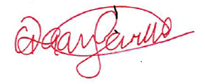
Date: | 03.02.2020
Subject Leader: | Abbie Holliday
Date:
Governor: | Tim Patrickson
Date:

